
Gisma University of Applied Sciences
Department of Computer Science

A Reliability-Aware Machine Learning Framework for Sentiment Classification of Social Media Posts

Yatin
GH1035214

Submitted in partial fulfilment of the requirements for the degree of
Masters of Data Science, AI and Digital Business

Under the supervision of
William morrison
Autumn 2026

Abstract
The current dissertation proposes and evaluates Reliability-Aware Sentiment Classification and Analysis (RASCA), an approach which was developed with the intention to not only test the performance of sentiment classification algorithms but also their reliability. Sentiment140 dataset is used to conduct a binary sentiment classification using TF-IDF unigrams and bigrams together with Logistic Regression, Multinomial Naive Bayes, Linear SVM, and Random Forest algorithms. Evaluation of the models is conducted by means of traditional metrics including accuracy, precision, recall, F1-score, ROC-AUC, and PR-AUC along with reliability-related metrics such as Brier score and Expected Calibration Error. Calibration of probability and selective prediction are employed to determine whether the confidence of the model matches its correctness and find predictions that can be automatically accepted or rejected by humans. The key value of RASCA is not introducing the new classification algorithm but offering a complete evaluation approach that incorporates accuracy, confidence reliability, calibration, selectivity, and high-confidence error analysis for sentiment classification based on TF-IDF.

Github Link: https://github.com/yatin00/Yatin-Dissertation
Dataset Link: https://www.kaggle.com/datasets/kazanova/sentiment140

Contents
Abstract 2
Chapter 1: Introduction 8
1.1 Background 8
1.2 Research Context 9
1.3 Problem Statement 10
1.4 Research Gap 11
1.5 Research Aim 12
1.6 Research Objectives 12
1.7 Research Questions 12
1.8 Research Contributions 13
1.9 Research Design 14
1.10 Dissertation Structure 14
Chapter 2: Foundations and Background 16
2.1 Introduction 16
2.2 Sentiment Analysis 16
2.3 Social-Media Text and Natural Language Processing 17
2.4 Text Preprocessing 18
2.5 TF-IDF Feature Representation 18
2.6 Traditional Machine-Learning Classifiers 19
2.6.1 Logistic Regression 20
2.6.2 Multinomial Naive Bayes 21
2.6.3 Linear Support Vector Machine 21
2.6.4 Random Forest 21
2.7 Prediction Confidence 22
2.8 Confidence Calibration 22
2.9 Reliability and Uncertainty 23
2.10 Accept/Review Decision Mechanism 23
2.11 High-Confidence Errors 24
2.13 Relationship between the Foundations and RASCA 25
Chapter 3: Related Work 26
3.1 Introduction 27
3.2 Traditional Machine Learning for Social-Media Sentiment Analysis 27
3.3 Machine Learning and Deep Learning in Sentiment Analysis 27
3.4 Sentiment140-Based Research 28
3.5 TF-IDF and Traditional Text Representation 29
3.6 Reliability beyond Predictive Accuracy 29
3.7 Confidence Calibration 30
3.8 Selective Prediction and Abstention 30
3.9 Reliability-Aware Sentiment Analysis 31
3.10 High-Confidence Errors 32
3.11 Critical Comparison of Existing Research 33
3.12 Research Gaps 34
3.13 Positioning of the RASCA Framework 36
3.14 Contribution of the Present Research 36
Chapter 4: Approach 38
4.1 Introduction 38
4.2 Overall Research Approach 38
4.3 RASCA System Architecture 39
4.4 Dataset 41
4.5 Data Preparation 41
4.6 Text Preprocessing 42
4.7 Train-Test Separation and Leakage Prevention 42
4.8 TF-IDF Feature Engineering 43
4.9 Machine-Learning Models 43
4.10 Model Training 44
4.11 Confidence Estimation and Calibration 44
4.12 Selective Prediction and High-Confidence Error Analysis 45
4.13 Implementation Environment and Reproducibility 47
Chapter 5: Evaluation and Results 49
5.1 Introduction 49
5.2 Experimental Configuration 49
5.3 Dataset Evaluation 51
5.4 Text Preprocessing and TF-IDF Representation 52
5.5 Cross-Validation Results 53
5.6 Final Test-Set Classification Results 54
5.7 Selection of the Best Model 55
5.8 Confusion Matrix Analysis 55
5.9 Confidence Calibration 56
5.10 Confidence Distribution 58
5.11 Confidence-Bin Analysis 59
5.12 Selective Prediction and Accept/Review Results 60
5.13 Risk-Coverage Analysis 61
5.14 High-Confidence Error Analysis 62
5.15 Examples of High-Confidence Errors 63
5.16 Evaluation of the RASCA Framework 64
5.17 Discussion of Results 65
Chapter 6: Conclusion 67
6.1 Introduction 67
6.2 Research Summary 67
6.3 Findings by Research Question 68
6.3.1 RQ1: How accurately can selected traditional machine-learning models classify positive and negative Sentiment140 posts using TF-IDF? 68
6.3.2 RQ2: To what extent do model confidence estimates correspond to actual prediction correctness? 68
6.3.3 RQ3: To what extent can confidence calibration improve the reliability of confidence estimates? 69
6.3.4 RQ4: Can selective prediction reduce the risk of incorrect automated sentiment decisions by referring lower-reliability predictions for review? 69
6.4 Achievement of Research Objectives 71
6.5 Research Contributions 72
6.6 Strengths of the Research 72
6.7 Limitations 73
6.8 Practical and Research Implications 74
6.9 Future Work 75
6.10 Final Conclusion 76
References 77
Appendices 80
Appendix A: Sentiment140 Dataset Information 80
A.1 Dataset Description 80
A.2 Dataset Preparation 80
Appendix B: Text Preprocessing Procedure 80
Appendix C: TF-IDF Configuration 81
Appendix D: Experimental Configuration 81

Content of Figures
Table 1: Critical comparison of related research 30
Table 2. Final experimental configuration 43
Table 3 Dataset preparation results 45
Table 4. Five-fold cross-validation results 46
Table 5: Logistic Regression before and after calibration 49
Table 6: Confidence-bin analysis 51
Table 7: RASCA selective-prediction results 52
Table 8: Examples of high-confidence sentiment-classification errors 55
Table 9: Final RASCA evaluation summary 56
Content of Figures
Figure 1: RASCA framework 23
Figure 2: RASCA Framework Architecture 37
Figure 3: Comparative F1-score of Logistic Regression, Multinomial Naive Bayes and Linear SVM 47
Figure 4: Confusion matrix of the selected Logistic Regression model 48
Figure 5: Reliability diagram before and after confidence calibration 50
Figure 6: Distribution of prediction confidence for the selected Logistic Regression model 51
Figure 7: Risk-coverage curve for the RASCA framework 54

Chapter 1: Introduction

1.1 Background
Social media creates a huge amount of the short text content via posts, comments, opinions, and reviews. This information includes thoughts around services, products, political events, companies, and ordinary life experiences. Manual analysis of these data is challenging due to the volume, velocity, and informal character of communications on social media platforms. Sentiment analysis is a computational approach for identifying the sentiments in the text, typically categorizing it as positive, negative, or neutral.
Some machine-learning techniques have been used for sentiment analysis since they allow establishing dependencies between text features and sentiment classes. A typical problem of binary sentiment analysis task is about discovering whether a text has positive or negative meaning. In this research, the conventional methods for identifying text representations imply using the Term Frequency-Inverse Document Frequency (TF-IDF) model followed by classifiers like Logistic Regression, Support Vector Machine (SVM), Multinomial Naïve Bayes, and Random Forest.
Despite the rapid rise in the usage of deep learning and transformer architectures, traditional techniques and machine learning algorithms still maintain significance as they are relatively easier to implement, require less computational power, and are simpler to interpret. Various contemporary studies include comparisons of the performance of different types of machine learning algorithms in Twitter sentiment classification. Anggraini et al. (2026) compare different models of machine learning and deep learning based on the Sentiment140 dataset.
Nonetheless, classification accuracy is not the only aspect when deciding whether a model based on machine learning is reliable. A model may yield a right answer with low confidence and vice versa. Standard evaluation criteria like accuracy, precision, recall, and F1 score may indicate how often a model makes correct predictions but does not explain whether the confidence level of the respective predictions can be trusted.
Recent studies have begun to pay attention to concepts like calibration of confidence, uncertainty estimation, and selective prediction. In this regard, Dong et al. (2025) have focused on the issue of calibration of confidence in a case of class imbalance. Huang et al. (2025) focus on the role of calibrated language models, and Rudner et al. (2025) explore how the notion of uncertainty-aware priors can benefit vision and language foundation models. Selective prediction is also of concern in this context. That is due to the fact that it enables the modeling body to skip the forecasting when there is not enough confidence. Thus, Mao et al. (2025) have examined the relationship of coverage and risk in the framework of selective prediction.
It should be noted that while all of the mentioned studies highlight the significance of the reliability issue, most of them are focused on the areas of deep learning, foundation/model studies, and large language model studies. There is little interest in how reliability-focused methods can be incorporated in lightweight traditional machine learning systems that deal with sentiment classification. This paper covers the above-discussed issue through developing and testing RASCA, which is a Reliability-Aware Sentiment Classification and Analysis framework.

1.2 Research Context
The research falls under the areas of natural language processing, sentiment analysis and trustworthy machine learning. The Sentiment140 dataset is employed, which is an extensive set of Twitter posts that have been classified for sentiment polarity. This dataset is beneficial in the research process since it is widely accepted as a standard dataset for binary sentiment classification and has been applied in recent comparative studies such as Anggraini et al. (2026).
The suggested framework utilizes TF-IDF technology to convert social media messages into vector feature representations. The method is applicable because it gives a clear and cost-efficient depiction of the significance of words as well as n-grams. Then, the created features are implemented to train classical machine-learning algorithms including Logistic Regression, Multinomial Naive Bayes, Linear SVM, and Random Forest.
However, the major aim of the research isn't merely to find the most effective classifier. It is necessary to find out how well the confidence predictions correlate with the correctness of predictions and whether the given confidence may assist in solving the problem of decision-making in a more controlled manner. This fact means that the framework being developed adds functions of confidence analysis, calibration, and selective prediction

1.3 Problem Statement
Automated sentiment classification systems have the benefit of processing massive amounts of social-media text much faster than traditional analysis methods. Standard machine-learning techniques can create effective and computationally efficient classifiers, especially when paired with the TF-IDF method.
Even so, most studies in this area evaluate the performance of their models with the help of the traditional evaluation metrics. However, such metrics do not show if the confidence in the predictions made is justified because of limitation within the nature of the analysis performed. Such results can achieve great F1 scores while delivering faulty predictions with reckless confidence.
This situation raises concerns over the use of the prediction systems in automated systems. In fact, a prediction can wrongly classify a message with sarcasm or irony, negating the intent of the speaker, which could turn out to be misleading. When the system produces inaccurate results with a high degree of confidence, there might be no reference of the message to a human specialist for review. Thus, the issue is not only related to the error in the classification from the perspective of the results; it requires addressing the issue of the model and its inability to properly evaluate the
Studies regarding calibration and selective prediction could be a possible solution to this challenge. In calibration, it is examined whether the predicted level of confidence corresponds to the real level of accuracy. In selective prediction, the model has the option not to make unclear predictions. Regardless, available techniques are usually considered independently of one another or utilized in more complex machine learning and language model situations.
The problem addressed by this dissertation is therefore:
Traditional sentiment-classification systems may produce accurate predictions but lack an integrated mechanism for evaluating confidence reliability, identifying uncertain predictions and analyzing high-confidence errors.

1.4 Research Gap
The review of the literature reveals four important gaps.
First of all, it shows that the majority of the studies on sentiment classification tend to focus on the prediction ability of the methods that has been applied. While comparing the performance of different models, bit emphasis is placed on accuracy, precision, recall and F1-score, but not much concern is paid to analysing the reliability of the obtained confidence measure.
Second, the literature provides considerable information about the state of confidence calibration, but mostly within deep-learning classifiers, large language modules or foundation models. Recent articles by Dong et al. (2025), Huang, Lu and Zeng (2025) and Rudner et al. (2025) make us aware of the importance of reliable confidence; however, they do not address this issue as applied to lightweight traditional models of sentiment classification.
Third, it becomes evident that confidence calibration and selective decision making are not always incorporated in one end-to-end sentiment analysis framework. In principle, a calibrated score is likely to be useful, but its practical application can bring considerable benefits if this score is used to make a decision whether the prediction should be automated or referred for reconsideration.
Fourth, high-confidence errors are not always processed extensively. These errors are significant since they could be more challenging to detect through confidence levels. Some linguistic features like sarcasm, irony, negation, ambiguity and colloquial expressions can cause the model to arrive at an erroneous decision while showing high confidence.
The gap which this dissertation aims to fill is therefore the inadequate development and assessment of classification performance, confidence calibration, selective prediction and high-confidence errors evaluation in the lightweight TF-IDF-based classical machine learning sentiment framework.
RASCA does not claim that TF-IDF, calibration and selective prediction are in themselves new techniques. Its contribution lies in bringing together these elements in one experimental scheme and testing their effectiveness in the process of reliable sentiment classification.

1.5 Research Aim
The aim of this dissertation is:
To develop and experimentally evaluate a reliability-aware machine-learning framework for binary sentiment classification of social-media posts by integrating TF-IDF-based traditional machine-learning models with confidence estimation, confidence calibration, selective prediction and high-confidence error analysis.

1.6 Research Objectives
A set of objectives helps channel the aim of the research as shown below:
- To study the Sentiment140 dataset, for conducting binary sentiment analysis of the dataset
- To develop a TF-IDF (term frequency-inverse document frequency) based feature extraction for social media text.
- To implement the traditional machine learning algorithms like Logistic Regression, Multinomial Naive Bayes, Linear SVM and Random Forest.
- To compare the accuracy of the abovementioned models.
- To study the relationship between model certainty and accuracy.
- To study the concept of confidence calibration and see if it helps in assessing accuracy.
- To design an approach of selective prediction.
- To investigate the nature of the errors which result with high certainty, and the possible linguistic signals behind these errors?
- To assess the RASCA system by the means of standard and reliability metrics like F1-score, ROC –AUC score, PR-AUC score, Brier score, and possible other relevant metrics.

1.7 Research Questions
The research questions examined in the dissertation are:
RQ1: How accurately selected classical machine learning models classify Sentiment140 positive and negative posts with TF-IDF features?
RQ2: To what degree does the confidence level of the model match the true indication or not?
RQ3: To what extent does the calibration of the confidence estimate improve the quality of the estimate?
RQ4: Can the selective prediction diminish the probability of a wrong sentiment decision via by sending the less capable predictions to the review?
RQ5: What linguistic features correlate with the errors in the sentiment classification obtained with a high level of confidence?
RQ1 establishes the predictively baseline of the research. RQ2 and RQ3 study the reliability of the confidence level. RQ4 shows the practical utility of the decision making based on the confidence level, while RQ5 focuses on the causes of errors that happens with a great confidence.

1.8 Research Contributions
The crucial point of this thesis is the establishment of the RASCA framework and its verification through experiments.
The first achievement of the work is that it creates a repeatable sentiment-classification process that relies on TF-IDF methods and certain classical machine-learning approaches, thereby presenting a reliable basis for estimating effectiveness in terms of forecasting and reliability.
The second achievement lies in distinguishing the presence of confidence analysis in the process of classification. The study looks into whether confidence values shed light on whether predictions indeed turn out to be correct since they are treated as being equally very reliable without any differentiation.
The third achievement refers to the establishment of the connection between confidence calibration and selective prediction. The RASCA method analyzes an Accept/Review approach where predictions with a great degree of certainty are immediately taken into software processing while more questionable predictions need a close analysis.
The fourth achievement lies in the evaluation of errors with a great confidence level. This contributes to a deeper comprehension of situations when the model is confident but wrong and can highlight linguistic shortcomings undetectable through the analysis of general results.

1.9 Research Design
The research employs applied, experimental and developmental research design. The experimental component consists of training and testing classical machine-learning classifiers on Sentiment140 dataset. The developmental component involves adding reliability-oriented components to the classification pipeline.
The methodology used involves preprocessing of data, extracting features using TF-IDF, training of models, estimating confidence, calibrating and selective prediction. The models are evaluated based on standard classification metrics and reliability-oriented ones. Cross-validation and a separate test set is used when appropriate to lessen the chances of over fitting and data leakage.
The study does not seek to implement a new architecture of deep learning. The objective is to find out whether a simple and affordable classical machine-learning pipeline is able to provide adequate information about reliability.

1.10 Dissertation Structure
The dissertation is organized into six main chapters.
Chapter 1 – Introduction presents the research background, problem statement, research gap, aim, objectives, research questions, contributions, and scope and research design.
Chapter 2 – Foundations and Background explains the technical concepts required to understand the research, including sentiment analysis, social-media text processing, preprocessing, TF-IDF, traditional machine-learning classifiers, confidence estimation, calibration, reliability and selective prediction.
Chapter 3 – Related Work critically reviews existing research on traditional and deep-learning sentiment classification, Sentiment140, confidence calibration, selective prediction and reliability-aware machine learning. It identifies the limitations that motivate the RASCA framework.
Chapter 4 – Approach describes the proposed framework, dataset, preprocessing procedures, feature engineering, machine-learning models, confidence estimation, calibration, selective prediction, implementation environment and reproducibility procedures.
Chapter 5 – Evaluation and Results presents the experimental setup and results. It compares model performance, evaluates confidence reliability and calibration, investigates selective prediction and analyses high-confidence errors.
Chapter 6 – Conclusion summarizes the findings, evaluates the achievement of the research objectives, discusses the contributions and limitations, and proposes directions for future work.
Overall, the dissertation follows the progression from the research problem and literature gap to the technical framework, implementation, experimental evaluation and final conclusions.

Chapter 2: Foundations and Background

2.1 Introduction
This section deals with the technical understanding necessary to comprehend the introductory material discussed in the Reliability-Aware Sentiment Classification and Analysis (RASCA) framework. This part of the material should primarily refer to the theories necessary for methodology and experimental evaluation and should not offer a thorough survey of any research work.
The field of sentiment analysis is gaining importance and has emerged as a significant application area for natural language processing due to the rapid increase in the volume of user-generated content shared on social-networking sites and online platforms. Recent literature reviews indicate that various methods such as machine learning, deep learning, and lexicon-based techniques can all be considered as the leading methodologies used in this field of knowledge (Shin et al., 2025).
The current study is based on the classification of sentiment into two categories with traditional machine learning techniques and TF-IDF representations. Nevertheless, the research goes beyond normal classification capability and studies the reliability of individual predictions. Confidence calibration has drawn attention to the importance of confidence estimates in decision support from machine learning predictions, as a model can provide correct predictions in general, while generating badly calibrated confidence estimates.

2.2 Sentiment Analysis
Sentiment analysis is a type of natural language processing that aims at identifying the sentiments or emotions expressed in text. In a classification task, one aims at converting non-structured information to one or more overall sentiment categories.
Surveys conducted recently indicate that the sentiment analysis is being applied in social media monitoring, customer feedback, online reviews, and other types of user-generated content. New methods include classical approaches of machine learning and deep learning, lexicon-based methods, and new hybrid systems.
There are different levels of sentiment analysis. At first, the document-level sentiment analysis gives an overall sentiment of the document or the post. Then the sentence-level analysis reveals sentiments in separate sentences. Aspect-based analysis, on the contrary, studies different aspects of an object.
The present study deals with the binary sentiment analysis, which assigns each social media post as either positive or negative. Thus binary classification is a simpler option for studying reliability of prediction than working with multiple sentiment classes.
In process of training the model learns the relationship between text features and examples with labels.After training the model can be used to predict sentiment of previously unseen text.New research still shows that traditional machine learning methods can be successfully utilized in social media sentiment classification. For instance, Brandão et al. (2025) have employed traditional classifiers like Naïve Bayes and Support Vector Machines for their experiments with social media data, whereas Gupta and Gautam (2026) have applied Logistic Regression, Support Vector Machine and Naive Bayes with help of TF-IDF features for analysis of Sentiment140.

2.3 Social-Media Text and Natural Language Processing
Social media posts are different from standard written discourse because users write non-formally and in a random way. Posts can contain abbreviations, different spelling, hashtags, mentions, links, emojis, duplicated letters or symbols and slang words.
The current studies highlight informal language and contextual interpretation as important problems in the field of sentiment analysis on social media platforms. The relevance of these problems becomes more important in light of short messages that lack a substantial linguistic basis for interpretation. Natural language processing is the technology that allows transforming human language into a form that can be processed by computer algorithms.
TF-IDF is used for the main feature representation within RASCA. This means that preprocessing and feature representation are important parts of the system because they directly determine what type of information will be available to the classifier. The reliance on the traditional formulation is confirmed by the modern studies that have shown that traditional machine learning approaches continue to be useful in the area of social media sentiment classification when appropriate preprocessing and feature development are applied (Brandão et al., 2025).

2.4 Text Preprocessing
Text processing is a stage of changing unprocessed text data into an effective format for data analysis. Social media data include many text forms that make traditional text processing problematic, such as URLs, mentions, inconsistent use of capital letters, hash tags, and redundant letters.
The main steps of text processing include:
- working with lower case characters,
- processing URLs,
- handling user mentions,
- working with hash tags,
- discarding unnecessary characters,
- normalizing the presence of white spaces,
- tokenization,
- optional processing of stop words,
- working with punctuation,
- working with negations, and
- Preserving identical records if they are needed.
The approach to text processing must depend on the characteristics of the studied data and the goals of the investigation. Too severe processing may lead to losing precious data that could be used for sentiment analysis purposes. For instance, the research on Sentiment140 conducted by Gupta and Gautam (2026) studied semantic normalization regarding slang, negation, URLs, mentions, and specialized tokenization prior to using the TF-IDF approach. The RASCA approach shows a unique scheme of social media text processing as the approach simplifies social media texts while making use of important sentiment information.

2.5 TF-IDF Feature Representation
In order to process data using machine learning algorithms, it is necessary to use numerical input. Text is unstructured data, which means it has to be converted into numerical data through the use of feature extraction methods.
TF-IDF is one of the frequency-based approaches that calculate a weight for each term based on its frequency in documents and collection of documents that it appears in.
The idea is very simple: the terms that are common across the whole collection are not very informative, while selective ones can have a relatively higher weight.
Text classification tasks conducted using the Sentiment140 corpus is based on TF-IDF representation.
Gupta and Gautam (2022) used TF-IDF features in their classification work, employing various classifiers, such as Logistic Regression, SVM, and Naive Bayes techniques.
TF-IDF can be presented in a different form with the help of n-grams, which is a term used for the sequence of n items from the population.
Unigram represents a single token, while bigram is two tokens that follow one another.
For instance:
- "not"
- "good"
- "not good"
Using unigrams and bigrams for certain phrases allows capturing local word connections important from the viewpoint

2.6 Traditional Machine-Learning Classifiers
Once we transform text data into the TF-IDF format, we can train a supervised machine-learning model to recognize the sentiment category.
Studies that examined classical classifiers for social media sentiment analysis go on. Brandão et al. (2025) focused on testing classical algorithms like Naïve Bayes and SVM with the help of Neural Networks. Gupta and Gautam (2026) tried to examine Logistic Regression, SVM, Naïve Bayes, and ensemble methods using TF-IDF and other text approaches for detecting sentiment on Sentiment140.
At the end of the research, RASCA implements three major classifiers:
- Logistic Regression
- Multinomial Naïve Bayes
- Linear Support Vector Machine
Random Forest method is mentioned as a relevant method of traditional machine learning below but was excluded from the final comparison of RASCA model conclusions.

2.6.1 Logistic Regression
Logistic Regression is a type of supervised classification algorithm that determines the likelihood that a certain instance belongs to a particular class by applying a logistic function. This probability can be turned into a class prediction if a proper decision boundary is chosen.
Logistic Regression is very useful for high-dimensional and sparse text data since linear relationships exist between the input variables and the dependent variable, benefiting from its ease of implementation and transparency.
Recent studies related to Sentiment140 provide evidence for the consistent performance of Logistic Regression, even with TF-IDF features, such as the work by Anggraini et al. (2026), who compared the performance of a Logistic Regression model in the TF-IDF setting and a BiLSTM model on Sentiment140 dataset and found out that the classical model is applicable here.

2.6.2 Multinomial Naive Bayes
Multinomial Naive Bayes is known for its usage as a probabilistic classifier for text classification. The method calculates the likelihood of input features being classified into each class and uses this information with the prior probability of various classes to make predictions.
For text classification, the multinomial concept is suitable for cases when a representation of the problem is based on term frequency or similar features. The main benefit of Multinomial Naive Bayes is its simplicity in terms of computation. Thus, this method is applicable to cases when one is analyzing large collections of text. Nevertheless, there are limitations regarding the assumptions underlying this method.
The limitations of the method urged researchers to consider using it as a comparison point while analyzing sentiments expressed in social media posts (Brandão et al, 2025; Gupta and Gautam, 2026).
RAE Multinomial Naive Bayes serves as a reference point for comparing against Logistic Regression and Linear SVM in RASCA.

2.6.3 Linear Support Vector Machine
A Support Vector Machine focuses on finding the dividing line and dividing area among classes in the given feature space. The classifier attempts to establish a separating hyperplane as well as getting a suitable margin between classes. The use of Linear SVMs is most significant for text classification because text representations such as TF-IDF give rise to high-dimensional and sparse feature matrices. Studies related to Sentiment140 still demonstrate efficacy of the method based on the SVM and TF-IDF.

2.6.4 Random Forest
Random Forest uses multiple decision trees in its collective decision-making process. Every tree provides a possible solution, and in the end, all solutions are merged. Random Forest is able to understand and show non-linear relationships and dependencies among the features. Recent studies on making decisions about the mood of people also include it in comparison with other techniques such as Logistic Regression, SVM, and Naive Bayes (Gupta and Gautam, 2026).

2.7 Prediction Confidence
Confidence in machine-learning predictions can be understood in two ways:
- The predicted outcome of the classification; and
- The confidence in that prediction.
For example:
Sentiment = Positive, Confidence = 0.94
This high confidence shows that the machine-learning model is quite sure of the outcome, but one must note that it does not imply that this value is indeed an accurate estimation of the actual probability of the correctness. The most recent studies on the calibration of confidence point out that confidence estimation is very important since machine-learning systems can sometimes produce certain predictions whose levels of confidence do not generally reflect accuracy of these predictions (Dong et al., 2025).
If a classifier works correctly, one would expect that predictions made with confidence level of 0.90 are correct not less than 90% of the time, while, in reality, it may be lower than that. If the prediction is made with higher confidence level but is correct less frequently, it means that confidence estimates are overconfident.

2.8 Confidence Calibration
Confidence calibration deals with the content of the predicted confidence and the accuracy of predictions made. In practical terms, including predictions made with a confidence score of 0.80 should indicate an appropriate amount of 80 percent of correct predictions. Calibration is a major aspect of machine learning because of the possible influence of confidence measurements on the acceptance of predictions. Current studies of calibration methods help define its complex importance in predicting events accurately (Dong et al., 2025).
Another way to measure calibration is using reliability diagrams that represent the ability to measure reliability by grouping together the confidence levels of the predictions of the model and comparing the confidence level with the amount of actual correct predictions. The RASCA framework provides a separation between calibration technique and classification performance. It is important, as calibration does not increase the accuracy of the classification but makes interpretation of the confidence scores easier.

2.9 Reliability and Uncertainty
The term reliability in machine learning describes the trustworthiness of model outputs meant for a specific purpose. Reliability in classification includes measures about both the prediction accuracy and the uncertainty of the individual output predictions.
A model can have overall high prediction accuracy but be still unreliable for some particular cases. For instance, a classifier may succeed at recognizing simple statements such as:
"I love this product."
but fail to interpret a sarcastic statement, e.g.:
"Fantastic, another update that messed up everything."
It looks like there is a significant difference between accuracy and reliability.
When measuring prediction accuracy the question is:
How often does the model make the right prediction?
Questions of reliability measure whether the model can be trusted.
The recent calibration study shows how important reliable confidence estimates are in decision-making and risk management (Dong et al., 2025). Similar problems are highlighted in recent research on sentiment analysis that emphasizes the problematic character of informal and context-dependent language of social media (Shin et al., 2025).
Thus, RASCA considers the reliability as an additional aspect of model evaluation and does not assume that the classifier, which has a high F1 score, is necessarily the most accurate classifier.

2.10 Accept/Review Decision Mechanism
The RASCA framework uses selective prediction via Accept/Review processing. If the prediction reaches a predetermined confidence level, it is accepted automatically. In contrast, predictions with low confidence require additional review.
The aim is not to eliminate uncertainty. The approach recognizes that uncertainty is a natural part of automated classification that needs to be dealt with. This method is especially useful if the cost of an erroneous automated decision is more significant than the cost of a manual inspection.
Recent works on reliability-aware sentiment analysis use reliability assessment, confidence calibration and selective acceptance of predictions instead of simplifying sentiment classification into a forced choice task. However, RASCA is, by design, aimed at proving the possibility of appending a reliability layer to regular classifiers without altering them in any other way.

2.11 High-Confidence Errors
High-confidence mistakes are occurrences of incorrect predictions that are still assigned a high confidence value by the classifier. Such mistakes are important because they demonstrate instances of misleading confidence on the behalf of the model.
Example:
“My phone has crashed again, Brilliant”
The word ‘Brilliant’ is identified as a straightforward positive sentiment marker by a classifier. But considering the general meaning of the remark, it expresses frustration. If a classifier determines a positive tone with very high confidence, the error is a high-confidence error.
The root causes of high-confidence errors could be:
- sarcasm
- irony
- negation
- ambiguous wordings
- slang
- contextual references
- rare expressions
- mixed sentiment
As recent investigations of social media sentiment analysis show, sarcasm and informal speech continue to be a challenge for standard methods of sentiment classification (Shin et al., 2023).
TF-IDF representation allows capturing essential linguistic patterns but does not model the whole contextual meaning of the message. Due to that, the model is likely to rely too much on closely related statement words even if the message has a different meaning. To that end, RASCA regards the high-confidence error analysis as a stand-alone procedure. Instead of counting the amount of errors only

2.13 Relationship between the Foundations and RASCA
The concepts introduced in this chapter provide the technical foundation for the RASCA framework.
The complete conceptual process can be represented as:

Figure 1: RASCA framework
First, preprocessing converts raw social-media content into a more consistent textual representation. Second, TF-IDF transforms the processed text into numerical features. Third, the machine-learning classifier generates a sentiment prediction. Fourth, confidence estimation provides information about the strength of that prediction. Calibration then examines whether the confidence values correspond appropriately to actual correctness. Selective prediction uses the resulting confidence information to control the degree of automation.
Finally, high-confidence error analysis investigates cases where the classifier remains incorrect despite expressing strong confidence.

Chapter 3: Related Work

3.1 Introduction
With the great advancements in Natural Language Processing (NLP), sentiment analysis is playing a significant role due to the massive amounts of views and opinions expressed through social media platforms. Large quantities of irregular and informal short texts are collected from platforms such as Twitter/X, hence helping automated sentiment classification systems, but it comes at a price of several technical challenges.
Previous literature review suggests that sentiment analysis techniques are still derived from traditional machine learning (ML) and developing more advanced deep learning (DL) and language models based approaches (Shin et al., 2025; Albadarneh et al., 2025).
This paper aims to explore the Reliability-Aware Sentiment Classification and Analysis (RASCA) framework by identifying five crucial domains that are interconnected: traditional ML designed for sentiment analysis, research based on Sentiment140, feature representation, confidence calibration and selective prediction. Further in the paper, the limitations of related work will be analyzed alongside an explanation of how RASCA overcomes these limitations.

3.2 Traditional Machine Learning for Social-Media Sentiment Analysis
Although deep learning methods are rapidly being developed, traditional machine learning methods are still being used for the task of sentiment analysis. Traditional machine learning algorithms, such as Logistic Regression (LR), Multinomial Naive Bayes (MNB), Support Vector Machines (SVMs), decision trees and ensemble methods, remain relevant and incredibly efficient, especially when handling sparse text representations such as TF-IDF.
A study conducted by Shin et al. revealed that there has been a shift in sentiment analysis from lexicon-based and classical machine learning methods to neural network and transformer based methods. However, these classical machine learning models should not be overlooked as they still give a very solid starting point for everyone who works in the field of sentiment analysis by showing great performance with much less computational cost.

3.3 Machine Learning and Deep Learning in Sentiment Analysis
Advancements in deep learning have made a great shift in research in sentiment analysis. Modern techniques such as Recurrent Neural Networks (RNNs), Long Short-Term Memory (LSTM), Convolutional Neural Networks (CNNs), transformers and pre trained models allow incorporating the contextual information the traditional methods based on the bag-of-words approach excluded.
Studies in this area prove that deep learning is becoming an important trend in social media sentiment analysis. Albadarneh et al. (2025) noted that this modern technique is widely used in this area making it possible to analyze the sentiment in real time. Shin et al. (2025) provide a valuable insight into the transition from traditional to deep learning technologies.
Nevertheless, more advanced models do not exclude traditional machine learning research. A relevant study (Anggraini et al., 2026) compared Logistic Regression with TF-IDF with BiLSTM model results and found that the accuracy of Logistic Regression made up 73.5% while that of BiLSTM was just 69.17%. Although the research was limited to 10,000 tweets only and cannot be compared to the larger experiments by this dissertation, it still proves that traditional models along with good features representation are still viable concerning the informal character of social media texts.

3.4 Sentiment140-Based Research
The Sentiment140 dataset is one of the most popular datasets used for binary Twitter sentiment classification. It is suitable for comparison purposes due to its large size and the high quality of the classification being performed (positive/negative).Recently published studies have presented findings obtained from experiments involving Sentiment140. For example, Anggraini and colleagues (2026) presented research that involved the application of Logistic Regression using the TF-IDF method and a deep learning technique known as BiLSTM on the subset of 10,000 tweets taken from Sentiment140.
J. Gupta et al. (2026) carried out a study that involved various machine learning algorithms, including Logistic Regression, SVM, Naive Bayes and ensemble models. In their study, the researchers put significant emphasis on the use of semantic text normalization in combination with TF-IDF and classification performance of the classification models used and identified SVM with TF-IDF bigrams to be the best-performing algorithm.
However, the research studies listed above primarily focus on the classification performance of the various models employed. Through evaluation of the accuracy, F1-score and the relevant classification measures, the researchers are able to identify the best-performing algorithm.

3.5 TF-IDF and Traditional Text Representation
Text representation holds a crucial place in classic sentiment classification system. The TF-IDF model continues to be among the most popular ones in the field since it presents the text in a numerical schema while assigning a great significance to critical terms in the paper being analyzed in comparison to the whole corpus.
Contemporary studies continue to confirm the importance of TF-IDF model in the field of sentiment analysis on social media platforms. A publication of 2025 devoted to the study of the sentiment analysis of Twitter/X messages has revealed that TF-IDF is one of the most recognized methods of obtaining features in this area of research. The review has also noted the success of the Naive Bayes and SVM methods along with recent approaches based on deep learning technology.
The maintenance of the use of the TF-IDF method is especially important for RASCA, since it offers the possibility to represent data in a straightforward manner for the purposes of analysis with the use of old classification methods. Current investigation employs uni- and bigram TF-IDF features along with the use of Logistic Regression, Multinomial Naive Bayes and Linear SVM methods.

3.6 Reliability beyond Predictive Accuracy
It has been discovered in recent research into machine learning that there is a significant difference between predictive accuracy and prediction reliability. While accuracy refers to the frequency of correct predictions by a classifier, confidence is an estimate of the degree of certainty of the model in its prediction. It is believed that, ideally, predictions made with 90% certainty should be correct in 90% of cases.
In some situations, however, the model can provide good predictions, but at the same time give the wrong estimates of its own confidence. The issue is significant when talking about results of the prediction, which can either be accepted or passed on to an operator. Recently, Dong and co-authors conducted a thorough research on the issue of confidence that provided a great overview of various existing methods used to calibrate confidence.
It has to be said that research into uncertainty has shown that confidence is an essential element of risk management and selective prediction. For example, Geng et al. looked at uncertainty estimation and confidence calibration as two of the methods that help improve the accuracy of AI prediction and make decisions based on the predictions.

3.7 Confidence Calibration
Confidence calibration works on making the predicted values of confidence compatible with actual correctness. For example, suppose a model makes 1,000 predictions, having around 80% confidence level. A well-calibrated model forecasts approximately 80% accuracy for the given confidence group. Calibration is termed as bad if the model is non-systematic overestimation or underestimation of the results.
Recent researches show that calibration is an important feature of reliable ML systems. Dong and others (2025) deal with the problems of calibration under class imbalance and discuss various techniques of calibrating and evaluating confidence reliability. They focus particularly on deep learning classification; however, their problem is important for traditional machine-learning models’ systems as well.
Recent research outcomes connected calibration to decision-making process based on the confidence of the prediction done by the model. Bodhwani et al. (2025) study the cases of evaluation and calibration of the confident identification in the tasks of classification done by language models with an aim to identify the cases of model predictions realization and the necessity of human evaluation.

3.8 Selective Prediction and Abstention
Selective prediction enhances traditional classification processes by allowing for the possibility of abstention in scenarios where the model lacks confidence.
In conventional binary classification, the model must choose one of two answers:
- Negative
- Positive.
With selective prediction, an additional third answer is added:
- Review/Abstain.
This technique is applicable for real life as not all predictions need to be taken for granted.
In recent years, many studies have contributed to the development of the concept of abstaining. Schuster (2025) explains machine learning systems that use the principle of abstention, implying the use of the rejection option when the predictive model is unable to deliver a definite answer.
Hasan et al. (2025) provide a descriptive review of uncertainty estimation approaches and the principle of rejection showing selective classification as a process of introducing awareness of the limitations of the model into the automatic system. Likewise, Casacuberta and Kanade (2025) conduct research into selective prediction and fair abstention viewing abstention as a device improving precision. Thus, the results of the studies can be considered as evidence in favor of the theoretical framework of the RASCA mechanism of Accept/Review.

3.9 Reliability-Aware Sentiment Analysis
The notion of merging sentiment analysis with reliability assessment is among the rather neglected fields of study compared to traditional sentiment classification.
The majority of sentiment analysis research concerns accuracy of predictions. Here are some of the common research questions in this aspect:
- Which algorithm achieves the greatest accuracy?
- Which representation yields the best F1 score?
- Does deep learning outperform ordinary machine learning?
- Which data preprocessing technique enhances the classification accuracy?
These questions are meaningful but do not completely tackle the issue of reliability in implementation.
The last studies in sentiment analysis have been more open about the concept of reliability. As an example, Narejo et al. (2026) introduced the technology named SentiGuard, which implements the notion of uncertainty in sentiment analysis. Their research indeed indicates that the role of reliability is gaining the importance in research of this nature.
Unfortunately, SentiGuard is focused on complex sentiment analysis with consideration of uncertainty management, while RASCA aims at the conventional pipeline of text classification based on TF-IDF and ordinary machine learning classifiers followed by confidence calibration and selective prediction.

3.10 High-Confidence Errors
A powerful yet infrequently analyzed issue is the problem of high-confidence errors.
A high-confidence error can be determined by:
- the prediction of a certain category
- the prediction is connected with high confidence
- the prediction is false.
High-confidence errors are critical cases since they could lead to more serious consequences than low-confidence errors. While a low-confidence error is likely to attract a human validation, a high-confidence error does not require any human expertise.
The language used in social media differs in terms of some characteristics that can lead to the emergence of high-confidence errors, which are as follows:
- Sarcasm
- Irony
- Negation
- Slang
- Ambiguity
- Mixed sentiment
- Dependence on context
- Implicit ideas
- Unusual spelling patterns.
The literature review regarding social media sentiment analysis suggests that user-generated incoherent language still constitutes a major problem for automated systems of mood analysis (Albadarneh et al., 2023; Shin et al., 2023).
In this regard, the study of high-confidence errors provides data that could not be obtained through analysis of the aggregate accuracy. Both systems might demonstrate the same accuracy index, but they may have different types of errors and levels of confidence in the mistakes made.

3.11 Critical Comparison of Existing Research
The literature discussed above suggests that significant progress has been made in sentiment analysis research. While traditional machine learning is still an effective technique, deep learning has made contextual representation better, and there is growing concern in the recent literature with uncertainty and reliability. The main question thus must not be whether there has been research conducted on any particular component. Confidence calibration, uncertainty estimation, and selective prediction all appear to have received an increased amount of research attention. The more specific issue to be investigated is whether these components can be combined in a traditional social media sentiment classification approach that can be reproduced.
However, several limitations remain.
Table 1: Critical comparison of related research
Research area | Main contribution | Limitation relevant to RASCA
Traditional ML sentiment analysis | Efficient and interpretable classification | Usually focuses on predictive performance
Deep-learning sentiment analysis | Better contextual representation | Greater complexity and computational requirements
Sentiment140 studies | Benchmark comparison of sentiment models | Primarily performance-oriented
TF-IDF approaches | Efficient representation of sparse text | Limited contextual understanding
Confidence calibration | Improves interpretation of confidence | Often studied independently from sentiment classification
Selective prediction | Allows uncertain cases to be rejected | Often evaluated outside social-media sentiment
Uncertainty research | Provides methods for estimating reliability | Strong focus on neural/LLM systems
High-confidence error analysis | Identifies dangerous prediction failures | Less commonly integrated into sentiment pipelines
RASCA | Integrates prediction, calibration, selective review and error analysis | Focused on traditional ML and one benchmark dataset

3.12 Research Gaps
Based on the reviewed literature, five research gaps are identified.
Gap 1: Accuracy remains the dominant evaluation perspective
A considerable part of studies in sentiment analysis puts emphasis on the importance of quality measures: accuracy, precision, recall, and F1-score. These metrics are necessary for assessment of models; however, they do not enable researchers to know if their predictions are reliable. The method developed by RASCA adds further dimension while assessing results of models and analyzing confidence and calibration.
Gap 2: Limited integration of calibration with traditional sentiment classification
The recent research on calibration provides advanced methods for works concerning reliable levels of confidence, while the majority of such studies focus on neural networks and modern AIs. Compared to that, considerably less attention is dedicated to the classical traditional ML systems.RASCA analyzes the potential of calibration in terms of reliable confidence evaluation through the use of TF-IDF based traditional ML systems.
Gap 3: Selective prediction is not normally integrated into standard sentiment pipelines
Selective prediction enables systems to avoid making uncertain decisions. Unfortunately, traditional sentiment analysis experiments typically necessitate that the model classify every test instance. Enter RASCA, which has introduced the Accept/Review mechanism to allow less certain predictions to be flagged for review.
Gap 4: High-confidence errors require greater attention
The overall accuracy can conceal instances where a model is very certain but incorrect. Such mistakes are very significant for reliability-sensitive applications where confidence could lead to the automated acceptance of predictions. RASCA straightforwardly detects and assesses predictions with probabilities higher than a certain value.
Gap 5: The relationship between prediction, confidence and linguistic failure is insufficiently explored
Many times, a sentiment model may not give the right results due to sarcasm, irony, negation, slang, or context dependency. This implies that by linking linguistic properties with a high degree of confidence, we can understand better the reliability of the model. Therefore, RASCA combines the quantitative evaluation of reliability with the qualitative analysis of the most confidently classified errors.

3.13 Positioning of the RASCA Framework
The series of positions taken by RASCA is what makes it distinct as compared to any conventional study in the realm of classifier comparison.The aim here is to compare the classifiers, i.e. whether Logistic Regression, Multinomial Naive Bayes, or Linear SVM achieves a higher F1-score or not. The critical question here, however, is whether an output of a sentiment classifier would be accompanied by a confidence estimate providing further information on the reliability of prediction.
Therefore, the framework treats confidence as an additional experimental entity rather than some by-product of classification.It corresponds to the findings of the latest studies underlining the importance of uncertainty quantification, calibration, and selective prediction for the trustworthiness of machine-learning systems (Dong et al., 2025; Hasan et al., 2025).

3.14 Contribution of the Present Research
It is clear from the literature review that the methods employed by RASCA are not totally novel. The previously employed methods of TF-IDF, Logistic Regression, Naive Bayes, SVM, confidence calibration and selective prediction has been researched before.
It is necessary to define the contribution accurately.
The contribution proposed is that the above methods are integrated and tested in a single framework for the purpose of reliability-aware social media sentiment classification.
This framework has four main contributions:
- Integrated reliability evaluation. The classification evaluation will be done along with the reliability evaluation
- Confidence-based selective prediction method. Predictions which are below a specified confidence threshold can be reviewed rather than being accepted automatically.
- High-confidence error analysis
- The framework aims at analyzing the cases when high confidence doesn’t lead to correctness
- Reproducible traditional ML implementation.
The above method uses large public dataset of sentiment and behaves in a way that is computationally efficient traditional classifiers, allowing for the framework to be affordable and reproducible.
Thus, the contribution is methodological in nature rather than stating that the approach brings in some revolutionary classification method.

Chapter 4: Approach

4.1 Introduction
This chapter focuses on explaining the method and technical execution of the suggested Reliability-Aware Sentiment Classification and Analysis (RASCA) system. The intention of the system is to improve a traditional sentiment classification infrastructure by adding prediction confidence, confidence calibration, selective prediction, and high-confidence error analysis.
This study utilizes the Sentiment140 dataset and focuses on binary classification of social media posts into either positive or negative sentiment classes. Four standard machine-learning models are analyzed, including Logistic Regression (LR), Multinomial Naive Bayes (MNB), and Linear Support Vector Machine (Linear SVM), and Random Forest (RF). The text is presented as Term Frequency-Inverse Document Frequency (TF-IDF) features.
The method aims at two interconnected goals, which are to create a reliable classification benchmark using known machine-learning tools and to answer the question of whether the confidence of each individual prediction can be assessed and used for selective decision-making.

4.2 Overall Research Approach
The research makes use of a machine-learning experimental technique. A labeled dataset is split into development and final testing components. Data preprocessing and flower extraction are performed in the experimental process to avoid leakage of information between training and testing datasets.
- Major steps of the methodology encompass:
- Acquiring and analyzing a dataset.
- Setting a binary sentiment label.
- Data preprocessing.
- Train-test split.
- The TF-IDF feature extraction.
- Implementation of traditional machine-learning algorithms.
- Model effectiveness evaluation.
- Outputs-generation and testing.
- Confidence level calibration.
- Effectiveness check.
- Predictive adjustments.
- High-confidence mistakes analysis.

4.3 RASCA System Architecture
The proposed RASCA architecture consists of several sequential components.

Figure 2: RASCA Framework Architecture
The research makes use of a machine-learning experimental technique. A labeled dataset is split into development and final testing components. Data preprocessing and flower extraction are performed in the experimental process to avoid leakage of information between training and testing datasets.
The methodology has been chosen to employ basic machine-learning algorithms and avoid the necessity of designing novel machine-learning structures. This enables one to address questions related to the reliability of the model without putting the focus on the complexity of the model being tested.

4.4 Dataset
Sentiment140 dataset is used in this research, which is a large collection of Twitter messages designed to perform sentiment analysis. The dataset consists of short social-media texts along with their sentiment classes. For the binary classification challenge discussed in this thesis, the negative and positive sentiments are changed into two classes.
The table below shows how labels are mapped to the experimental class:
Original label | RASCA class
0: Negative
4: Positive
In this binary classification task, the neutral label category, if any, is not used in the original labelling scheme. The dataset is suitable for this research, given that it is a large corpus of the text to do experiments along with the components of RASCA. The dataset is loaded into the experiment and investigated before any preprocessing. The investigation process examines different class labels, as well as missing data, duplicates, and text field’s structure.

4.5 Data Preparation
Data preparatory steps take place prior to model training, in order to validate that the data being used for binary sentiment classification is acceptable and that other possible factors influencing the experiment should be controlled.
The main steps of the preparation phase are as follows:
- importing the data
- identifying relevant text and sentiment fields
- converting sentiment labels to binary classes
- removing labels that are not necessary for binary classification
- checking for missing values
- checking for duplicates
- looking into the class distribution
- Separating the text from the target variable.
The information about the class distribution is provided before training the model, as class imbalance may influence the findings. Therefore, the stratified train-test split is employed to maintain the relative distribution of sentiments.

4.6 Text Preprocessing
Messages that are sent through social media contain URLs, user mentions, hash tags, punctuation and informal expressions, hence the need to perform a preprocessing step before features are extracted.
The RASCA preprocessing includes the following actions:
- The transformation of cases of the text to lower case
- Dealing/removing of URLs
- Dealing/removing of user mentions
- Preservation of relevant content of hash tags
- Preservation of apostrophes preserved in case it matters
- Preservation of terms related to the negation
- The removal of unneeded text data
- Normalization of spacing

4.7 Train-Test Separation and Leakage Prevention
Data leakage takes place when the information from the test data sets affects the training of machine learning models, resulting in unrealistic positive evaluation results.
In order to avoid such instances, the dataset is separated into training/developing data and test data prior to the actual evaluation. TF-IDF utility is modeled on the training data and then applied to the untested data. The same principle is applied to model development and tuning. Hence, the dataset is separated into training and testing sets prior to the evaluation, which allows for correct estimation of the model’s performance when dealing with new data.

4.8 TF-IDF Feature Engineering
Once preprocessing is completed, every social media post is converted into a numerical representation called the TF-IDF vector. The RASCA model employs word-level unigrams and bigrams, thus allowing contribution from both individual words and word pairs. For instance, the phrase "not good" can be represented by combining the following features:
"not"
"good"
"not good"
As a result, the model has the ability to capture small local phrases that may help in the sentiment classification process.
The implementation has the limitation of the maximum of 300,000 TF-IDF features. This limitation of features contributes to saving memory and processing power while allowing for an extensive vocabulary for the classification task.

4.9 Machine-Learning Models
Four traditional machine-learning classifiers are implemented.
4.9.1 Logistic Regression
Logistic Regression offers a linear classification approach that works well with high-dimensional, sparse textual data. The outcome can be interpreted as part of the confidence analysis. The purpose of including Logistic Regression is to have an effective and interpretable baseline for binary text classification.
4.9.2 Multinomial Naive Bayes
Multinomial Naive Bayes is a probabilistic classifier that is popularly used for text classification tasks. Efficiency is the key advantage of employing the Multinomial Naive Bayes approach.
4.9.3 Linear Support Vector Machine
The method is most appropriate for high-dimensional sparse representation data. One of the methodological limitations of SVM lies in the fact that its decision function does not provide the probability measure.
4.9.4 Random Forest
Random Forest is a set of decision trees. Each tree makes a prediction, and the joint result of all trees creates the output. The implementation of the Random Forest allows for the establishment of a nonlinear ensemble baseline against which linear/ probabilistic models can be evaluated.

4.10 Model Training
The selected models are trained using the TF-IDF representation generated from the training data. A 5-fold Stratified Cross-Validation strategy is used during development where appropriate. Stratification preserves the class distribution within the folds. The use of cross-validation provides a more robust estimate of development performance than relying on a single training partition during model selection.

4.11 Confidence Estimation and Calibration
Logistic Regression uses predicted probabilities as the main measure of confidence. The model provides a prediction of probability for the positive case for each test sample. The confidence of both the prediction and the class that was chosen is illustrated by the probability for the positive class. As an example, if the tweet was confirmed as positive with the probability of being in the positive class of 0.94, the confidence in the prediction equals 0.94. By this method, it is possible to find out how confident the predictions were.
The confidence was studied by making use of confidence intervals that varied from 0.50 up to 1.00. In doing so, the predictions were spaced into different bins which revealed the correlation between the confidence indicator and the accuracy of predictions. It is critical to point out the fact that a high confidence item might not mean that the prediction is correct.
Secondly, through the implementation of the RASCA method, the aspect of probability calibration was included. Calibration has a purpose of enhancing the level of consistency of predicted confidence from the observed level of prediction accuracy. In an ideal calibration process, predictions with the level of confidence equal to approximately 0.80 would be correct in 80 percent of cases that fall into the corresponding deserve group. The utilization of calibration leads to getting a reliability approach that is not typical to the other approaches regarding accuracy, precision, and other measures. Sigmoid technique was used for the application of the calibration for the logistic regression model that was chosen before, but the process of calibration did not occur during the process of choosing a classifier. It was applied intentionally as the goal of calibration is not to increase the classification accuracy but improve its interpretability.
In addition, the ECE metric was used for measuring the calibrating level which involves comparison of estimated confidence and rate of actual correctness of decision-making. The lower ECE level indicates the more accurate predicted confidence that people get from samples.

4.12 Selective Prediction and High-Confidence Error Analysis
The next step of the RASCA framework is selective prediction. The goal of selective prediction is to help the system distinguish between predictions that are automatically accepted and those that need to go through further examination. This gives a practical way of dealing with uncertainty instead of requiring a classifier to treat every prediction as the same level of reliable.
The implementation of this process is done by using Accept/Review process. If the confidence level for a prediction is equal to or higher than a specific threshold, that prediction will be labeled as Accepted. If the predictions are below the threshold, they will be labeled as Review. In this study, the confidence thresholds of 0.60, 0.70, 0.80, 0.90, and 0.95 are taken into consideration.
The basic decision rule can be represented as:
If confidence ≥ threshold → Accept
If confidence < threshold → Review
The balance between reliability and automation is determined by the threshold used. A lower threshold allows for more predictions to be processed automatically but may lead to more erroneous predictions. A higher threshold means that fewer predictions will be accepted, but accepted predictions are expected to be more accurate.
Two important metrics need to be calculated to analyze this trade-off: coverage and selective risk. Coverage is the proportion of predictions processed automatically while selective risk denotes the proportion of erroneous predictions amongst accepted predictions. Analyzing the relationship between these metrics help find how effectively confidence can be used to control automated decision making.
Selective prediction analysis is important since RASCA does not aim to achieve maximum classification accuracy but rather to understand whether there are conditions under which predictions acceptable for automatic processing would have proper reliability. In other words, it helps identify low-confidence predictions that require manual review.
Apart from its selective prediction functions, RASCA is capable of conducting analysis pertaining to errors that evoke high levels of confidence. High-confidence errors refer to instances in which the classification system wrongly classifies but with a high level of confidence. The significance of high-confidence errors is that they indicate situations where something wrong can appear credible.
In the analysis of high-confidence errors the threshold for high confidence is set at 0.90. The instances in which the output prediction is equal to the threshold or above it are included in the analysis. The goal of the study is aimed not only at counting occurrences of high-confidence error but also at providing linguistic explanations for this phenomenon.
Thus, high-confidence error analysis adds qualitative to the limitations of the system. While the overall accuracy value might be quite satisfactory, the presence of high-confidence errors can be detected. The selective prediction, together with the high-confidence error analysis, broadens the scope of research as far as methodology goes.

4.13 Implementation Environment and Reproducibility
The RASCA framework has been utilized as an experimental pipeline that relies both on software and machine-learning and natural-processing algorithms. Its essence is designed in such a way as to not be computationally intensive while ensuring the reconstruction of the entire process of data preparation, feature extraction, construction of the models, and their evaluation.
It should be pointed out that Python is the main programming language used to implement the whole pipeline. While the data preparation is done using various libraries typical of Python programming, the modeling algorithm is applied through the Scikitlearn modules.The experimental pipeline operates in the same sequence: the Sentiment140 dataset is uploaded and checked first. The sentiment labels are transformed into the binary format used for research purposes. The preprocessed text is then analyzed with the corresponding algorithm. The preprocessed data are used to extract TF-IDF features which are then used for analyzing test data and training the models.
To reduce the possibility of information leakage, feature extraction is separated between the training and testing stages. The TF-IDF representation is fitted using training data and subsequently applied to unseen test data. Similarly, the test dataset is not used for model selection or parameter optimization. The research therefore maintains a separate test set for final evaluation. The experimental setup employs an 80/20 training-testing split and a constant random state of 42. The modeling process employs five-fold StratifiedKFold cross-validation. Stratification is necessary to maintain the distribution of sentiment classes among folds. All aspects of the experimental setting are kept constant so as to allow replication of the experiments and to make various models comparison understandable.
The implementation saves the major results of the experiment in order to enable an independent analysis of the results apart from the main process. Such results include the results of comparison of models, calibration results, results of confidence bins, results of selective predictions, high confidence errors, and the final summary of RASCA.
The replication of results is also achieved through maintaining the same experimental conditions and recording the configuration at each main step of the process. The same rules of preprocessing, feature extraction parameters, random state and evaluation procedure are used consistently. This reduces the chance of having experimental results´ dissimilarities due to modification of the processing pipeline not recorded.
The implementation is deliberately based on conventional techniques of machine learning and not on some new deep learning model. This is in compliance with the goal of the research to see

Chapter 5: Evaluation and Results

5.1 Introduction
In this chapter, an experimental evaluation of the Reliability-Aware Sentiment Classification and Analysis (RASCA) framework is discussed. The aim of this evaluation is to determine not only how accurately conventional machine learning techniques can classify social media posts as positive or negative but also whether the confidence levels produced by these techniques can help to make more reliable automated decisions.
The methodology of the evaluation presented in this chapter is similar to the one discussed in Chapter 4. The data from the Sentiment140 dataset were converted to a binary sentiment classification problem and processed by using the social media text preprocessing techniques as well as the TF-IDF feature extraction method. The three conventional machine learning algorithms were utilized in the current evaluation: logistic regression, multinomial naive Bayes and linear support vector machine (SVM). The cross-validation of the models was performed with the help of the stratified five-fold cross-validation technique as well as with the help of a separate stratified test set. The final model was selected based on the classification performance and was use further for probability calibration, confidence analysis and selective prediction.

5.2 Experimental Configuration
In this chapter, an experimental evaluation of the Reliability-Aware Sentiment Classification and Analysis (RASCA) framework is discussed. The aim of this evaluation is to determine not only how accurately conventional machine learning techniques can classify social media posts as positive or negative but also whether the confidence levels produced by these techniques can help to make more reliable automated decisions.
The methodology of the evaluation presented in this chapter is similar to the one discussed in Chapter 4. The data from the Sentiment140 dataset were converted to a binary sentiment classification problem and processed by using the social media text preprocessing techniques as well as the TF-IDF feature extraction method. The three conventional machine learning algorithms were utilized in the current evaluation: logistic regression, multinomial naive Bayes and linear support vector machine (SVM). The cross-validation of the models was performed with the help of the stratified five-fold cross-validation technique as well as with the help of a separate stratified test set. The final model was selected based on the classification performance and was use further for probability calibration, confidence analysis and selective prediction.
Table 2. Final experimental configuration
Parameter | Configuration
Dataset | Sentiment140
Original records | 1,600,000
Final modelling records | 1,596,406
Training records | 1,277,124
Testing records | 319,282
Classification task | Binary sentiment classification
Negative label | 0
Positive label | 1
Train/test split | 80/20
Random state | 42
Cross-validation | 5-fold StratifiedKFold
TF-IDF n-grams | 1–2
TF-IDF min_df | 5
TF-IDF max_df | 0.95
TF-IDF sublinear TF | True
Maximum TF-IDF features | 300,000
Models | Logistic Regression, Multinomial Naive Bayes, Linear SVM
Random Forest | Not used
RandomizedSearchCV | Not used
Calibration | Sigmoid
Calibration CV | 5-fold
Selective thresholds | 0.60, 0.70, 0.80, 0.90, 0.95
High-confidence threshold | 0.90

5.3 Dataset Evaluation
The last experiment made use of the complete valid Sentiment140 dataset after going through the processes of preprocessing and text validation. The original dataset consisted of 1,600,000 entries and six different columns: target, ids, date, flag, user and text. At the validation phase of the dataset, no missing entries or duplicate rows were found.
The original value for the target variable had two values for sentiment: 0 and 4, where the number of records for each sentiment was 800,000. These values were converted into binary values so that 0 represents negative sentiment and 1 represents positive sentiment. Thus, the final dataset remained perfectly balanced right before the phase of text validation.
In the last step of preprocessing, 3,594 records with empty cleaned text were excluded from the modeling dataset. Thus, the modeling dataset finally consists of 1,596,406 entries. The dataset was then divided using 80/20 stratified train-test split, which resulted in the creation of a dataset with 1,277,124 training entries and 319,282 test entries. The distribution of classes remained almost perfectly balanced, being 50.009% using the training set and 49.991% using the test set.
Table 3 Dataset preparation results
Stage | Records
Original Sentiment140 records | 1,600,000
Binary sentiment records | 1,600,000
Excluded because of original label | 0
Empty cleaned-text records removed | 3,594
Final modeling records | 1,596,406
Training records | 1,277,124
Test records | 319,282

5.4 Text Preprocessing and TF-IDF Representation
Prior to conducting feature extraction, the Tinder Data was cleaned. In particular, the cleaning process was beneficial for the elimination of Twitter-specific elements while leaving all the words and phrases that expressed certain emotions in the final experiment.
Then, TF-IDF algorithm was conducted where the frequencies of both unigrams and bigrams were calculated. In particular, the algorithm was configured so that the minimum frequency of the document was 5, maximum frequency was 0.95, sub linear term frequency was used and number of features was capped at 300,000.
Moreover, it is worth mentioning that TF-IDF vectorization was calculated using only the training data, while transformations of the test set were made later using the fitted vectorizer. Thus, this procedure helped to avoid information leakage related to the test set.

5.5 Cross-Validation Results
Five-fold stratified cross-validation was used to assess the consistency of the three candidate classifiers. The cross-validation procedure used shuffling with random state 42.
Table 4. Five-fold cross-validation results
Model | Accuracy Mean | Accuracy SD | Precision Mean | Precision SD | Recall Mean | Recall SD | F1 Mean | F1 SD | ROC-AUC Mean | ROC-AUC SD
Logistic Regression | 0.8197 | 0.0013 | 0.8132 | 0.0015 | 0.8299 | 0.0011 | 0.8215 | 0.0012 | 0.8991 | 0.0011
Multinomial Naive Bayes | 0.8031 | 0.0010 | 0.8091 | 0.0012 | 0.7932 | 0.0010 | 0.8011 | 0.0010 | 0.8847 | 0.0006
Linear SVM | 0.8101 | 0.0005 | 0.8048 | 0.0006 | 0.8189 | 0.0005 | 0.8118 | 0.0005 | 0.8903 | 0.0005

The outcomes of the cross-validation indicate that Logistic Regression performed the best in terms of average value of main evaluation metrics. Mean F1 score for Logistic Regression reached 0.8215, compared to 0.8118 for Linear SVM and 0.8011 for Multinomial Naive Bayesian classifier. Logistic Regression yields also the highest mean ROC-AUC value equal to 0.8991.
The small standard deviation indicates that the model performance was rather stable throughout the five folds. Thus, Logistic Regression gives the best baseline to compare against when conducting further evaluations.

5.6 Final Test-Set Classification Results
The outcomes of the final assessments match the information gleaned during the cross-validation process. Among the three models that were analyzed, Logistic Regression returned the highest rates in terms of accuracy, precision, recall, F1-score, ROC-AUC, and PR-AUC. Its accuracy stood at 82.34%, whereas the F1-score was at the level of 0.8248. Moreover, the model got the score of 0.9024 in terms of ROC-AUC and of 0.9031 with regard to PR-AUC. With Linear SVM’s F1-score being equal to 0.8142, it managed to take the second place. Meanwhile, Multinomial Naive Bayes was able to return the score of 0.8017. Therefore, this evidence confirms that Logistic Regression could be chosen as the best classifier in the system.
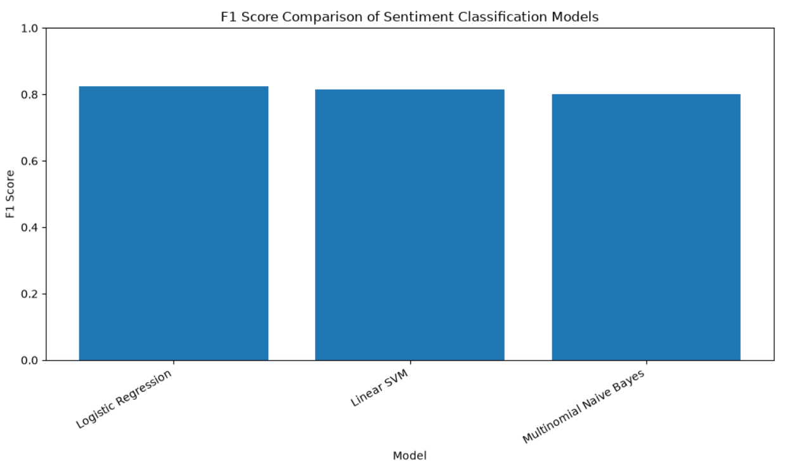
Figure 3: Comparative F1-score of Logistic Regression, Multinomial Naive Bayes and Linear SVM

5.7 Selection of the Best Model
Based on the final test results, Logistic Regression was selected as the best classification model.
The model achieved an overall accuracy of 0.8234. Its class-specific results were also relatively balanced. For the negative class, precision was 0.8288, recall was 0.8152 and F1-score was 0.8220. For the positive class, precision was 0.8181, recall was 0.8316 and F1-score was 0.8248.

5.8 Confusion Matrix Analysis
The confusion matrix provides a more detailed view of the errors made by Logistic Regression.
The model correctly classified 130,166 negative posts and 132,727 positive posts. It incorrectly classified 29,503 negative posts as positive and 26,886 positive posts as negative. The results indicate that the model identified positive posts slightly more effectively in terms of recall. Positive recall was 0.8316, while negative recall was 0.8152. This difference is reflected in the confusion matrix.
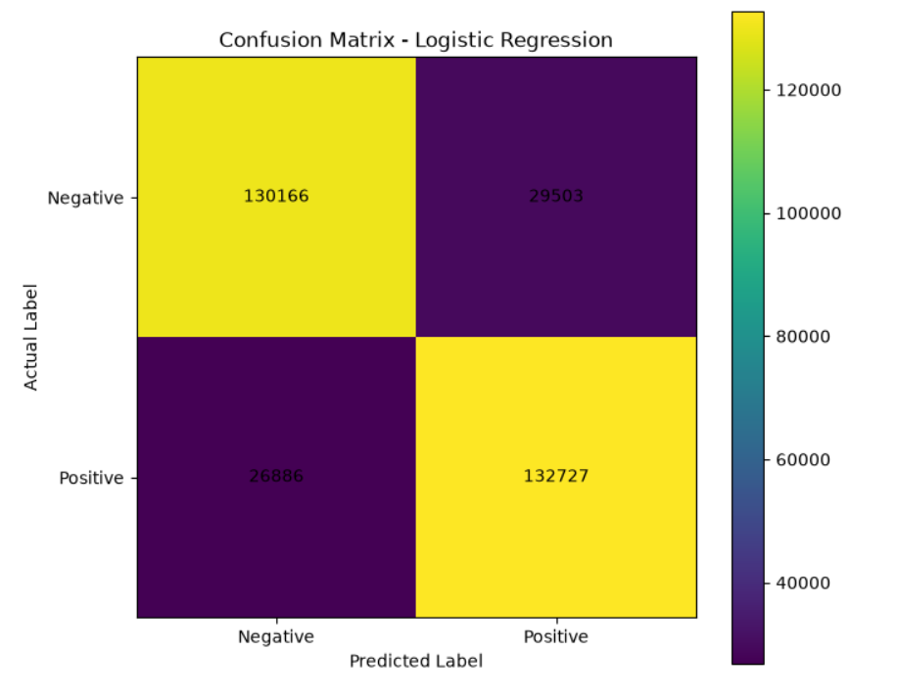
Figure 4: Confusion matrix of the selected Logistic Regression model
The confusion matrix should be presented as a heat map with actual sentiment on the vertical axis and predicted sentiment on the horizontal axis.

5.9 Confidence Calibration
After selecting Logistic Regression, the model was subjected to confidence calibration using sigmoid probability calibration. The purpose of this stage was to improve the relationship between predicted confidence and observed correctness.
The uncalibrated Logistic Regression model achieved an accuracy of 0.8234, F1-score of 0.8248 and Brier score of 0.125908. Following calibration, accuracy became 0.8224, F1-score became 0.8236 and Brier score became 0.126250.
Table 5: Logistic Regression before and after calibration
Metric | Uncalibrated | Calibrated
Accuracy | 0.8234 | 0.8224
Precision | 0.8181 | 0.8179
Recall | 0.8316 | 0.8293
F1 | 0.8248 | 0.8236
ROC-AUC | 0.9024 | 0.9015
PR-AUC | 0.9031 | 0.9022
Brier Score | 0.125908 | 0.126250
ECE | 0.017193 | 0.010625

The classification metrics changed only slightly after calibration. Accuracy decreased from 0.8234 to 0.8224 and F1 decreased from 0.8248 to 0.8236. Similarly, ROC-AUC and PR-AUC experienced small decreases. However, the ECE results show a different pattern. The uncalibrated ECE was 0.017193, while the calibrated ECE decreased to 0.010625. The experimental output explicitly identifies lower ECE as indicating better calibration.
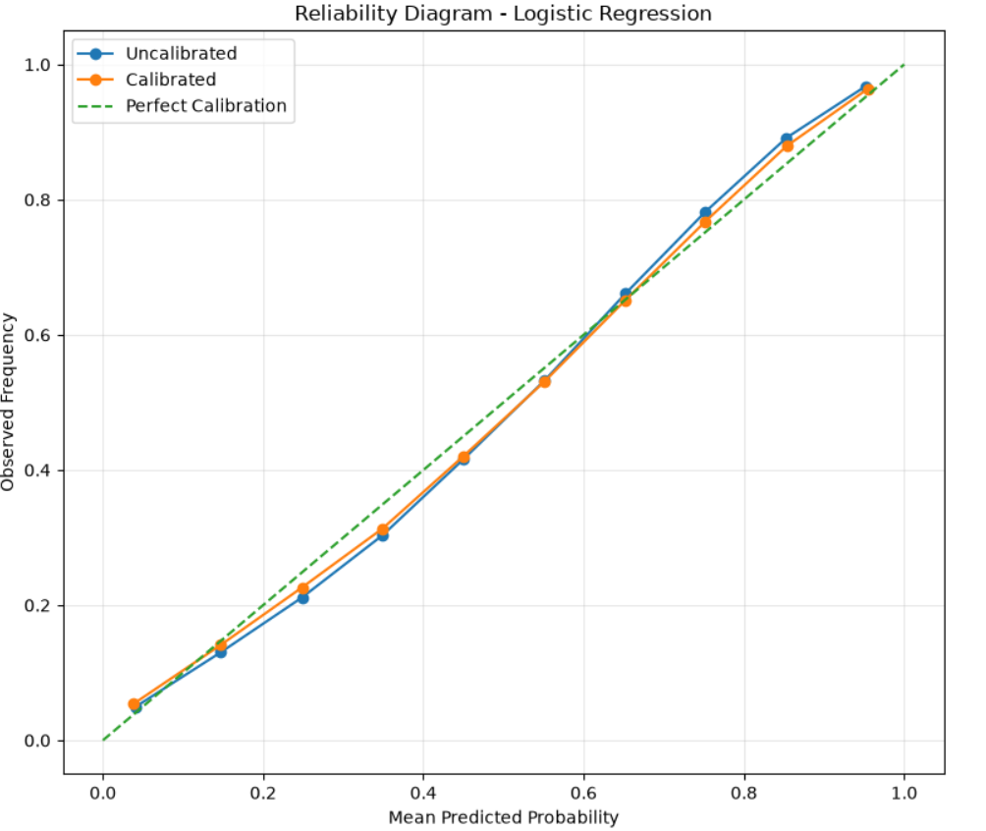
Figure 5: Reliability diagram before and after confidence calibration
The reliability diagram should compare the empirical accuracy of predictions against their estimated confidence and include the ideal calibration line.

5.10 Confidence Distribution
The confidence analysis was performed on all 319,282 test predictions generated by the selected model. The mean confidence was 0.814758, with a standard deviation of 0.146772. The minimum confidence was 0.50 and the maximum was 1.00. The median confidence was 0.848952. The first quartile was 0.698661, while the third quartile was 0.945914.
The distribution indicates that a substantial proportion of predictions received relatively high confidence. This is important because the RASCA framework uses confidence as the basis for deciding whether predictions should be automatically accepted or referred for review.
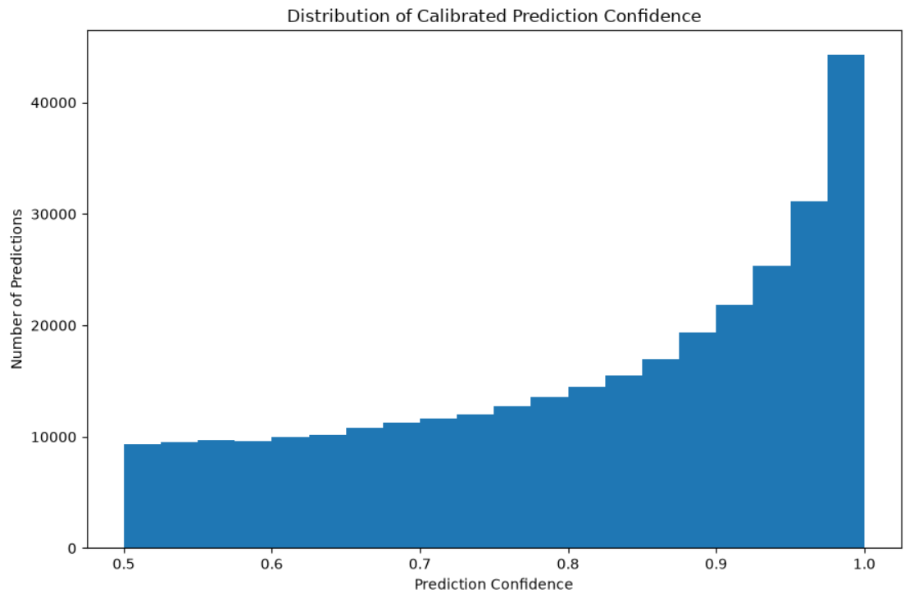
Figure 6: Distribution of prediction confidence for the selected Logistic Regression model

5.11 Confidence-Bin Analysis
To investigate whether confidence corresponds to actual correctness, the predictions were divided into six confidence intervals.
Table 6: Confidence-bin analysis
Confidence range | Predictions | Accuracy | Mean Confidence | Error Rate
0.50–0.60 | 38,215 | 0.5548 | 0.5504 | 0.4452
0.60–0.70 | 42,177 | 0.6680 | 0.6516 | 0.3320
0.70–0.80 | 49,945 | 0.7706 | 0.7517 | 0.2294
0.80–0.90 | 66,294 | 0.8700 | 0.8532 | 0.1300
0.90–0.95 | 47,233 | 0.9278 | 0.9262 | 0.0722
0.95–1.00 | 75,418 | 0.9707 | 0.9781 | 0.0293

The results show a strong monotonic relationship between confidence and observed accuracy. Accuracy increases from 55.48% in the 0.50–0.60 confidence interval to 97.07% in the 0.95–1.00 interval. At the same time, the error rate falls from 44.52% to 2.93%.
This provides important evidence for RQ2. Confidence is informative because higher-confidence predictions are substantially more likely to be correct. However, the results also show that confidence is not perfect: even within the highest confidence interval, 2.93% of predictions remain incorrect.
The relationship also provides the justification for the selective-prediction component of RASCA. If confidence can distinguish relatively reliable predictions from less reliable predictions, then confidence thresholds can be used to control the level of automation.

5.12 Selective Prediction and Accept/Review Results
The central reliability-aware experiment evaluated five confidence thresholds: 0.60, 0.70, 0.80, 0.90 and 0.95. Predictions meeting or exceeding the threshold were classified as Accepted, while predictions below the threshold were classified as Reviewed.
Table 7: RASCA selective-prediction results
Threshold | Accepted | Reviewed | Coverage | Review Rate | Accepted Accuracy | Selective Risk
0.60 | 281,067 | 38,215 | 0.8803 | 0.1197 | 0.8588 | 0.1412
0.70 | 238,890 | 80,392 | 0.7482 | 0.2518 | 0.8924 | 0.1076
0.80 | 188,945 | 130,337 | 0.5918 | 0.4082 | 0.9247 | 0.0753
0.90 | 122,651 | 196,631 | 0.3841 | 0.6159 | 0.9542 | 0.0458
0.95 | 75,418 | 243,864 | 0.2362 | 0.7638 | 0.9707 | 0.0293

The results demonstrate a clear trade-off between automation coverage and prediction risk. At the lowest threshold of 0.60, the system accepts 281,067 predictions, corresponding to 88.03% coverage. Accepted accuracy is 85.88%, while selective risk is 14.12%. At a threshold of 0.70, coverage decreases to 74.82%, while accepted accuracy increases to 89.24%. At 0.80, the system accepts 59.18% of predictions and achieves 92.47% accuracy among accepted cases.
At 0.90, coverage decreases to 38.41%, but accepted accuracy rises to 95.42%. Finally, at 0.95, only 23.62% of predictions are accepted automatically, but their accuracy reaches 97.07%. These values are directly reported by the final RASCA experiment. The results clearly demonstrate the fundamental coverage-risk trade-off. Increasing the confidence threshold reduces the number of predictions processed automatically but increases the reliability of those that remain.

5.13 Risk-Coverage Analysis
Risk-coverage analysis provides one of the most important evaluations of the RASCA framework. The relationship is straightforward. A lower threshold allows the system to automate a larger proportion of decisions, but the accepted predictions contain more errors. A higher threshold causes more predictions to be referred for review, but the predictions that remain in the automatic group are substantially more accurate.
The difference between the lowest and highest threshold is particularly important. Moving from 0.60 to 0.95 increases accepted accuracy from 85.88% to 97.07%, an improvement of 11.19 percentage points. However, coverage decreases from 88.03% to 23.62%. This demonstrates that RASCA can be configured according to the risk tolerance of a particular application.
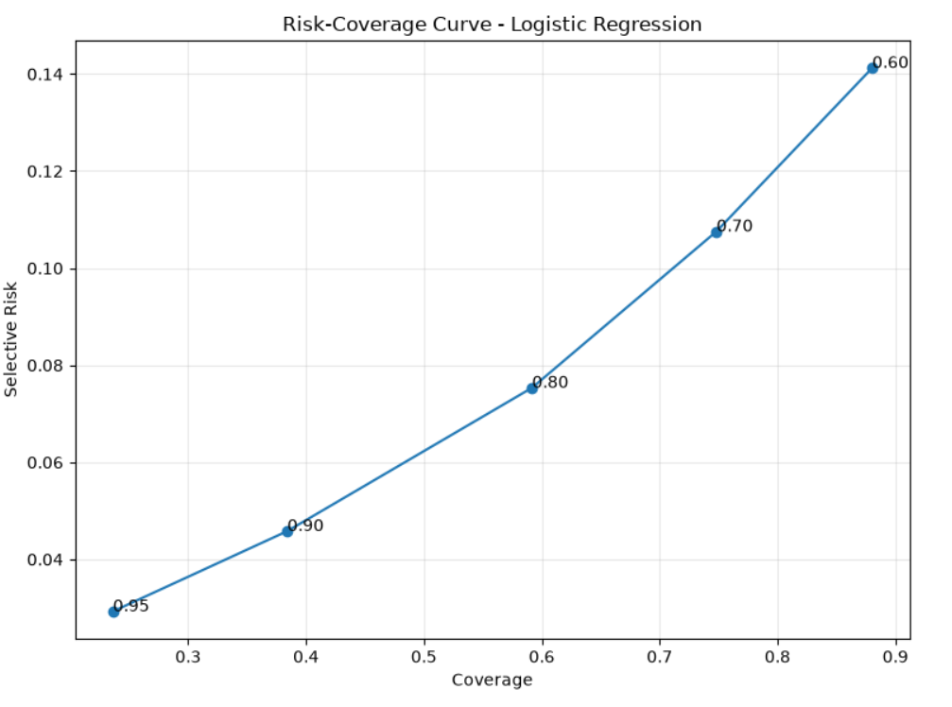
Figure 7: Risk-coverage curve for the RASCA framework

5.14 High-Confidence Error Analysis
A central objective of RASCA is to identify situations where a model remains highly confident but produces an incorrect prediction.
The experiment defined high-confidence predictions using a threshold of 0.90. A total of 122,651 predictions met this threshold, of which 5,619 were incorrectly classified. The resulting high-confidence error rate was 1.7599%, while the corresponding accuracy among high-confidence predictions was 95.4187%.
The result is important because it demonstrates that even a high-confidence prediction cannot be assumed to be correct. At the 0.90 threshold, approximately 1.76% of the automatically eligible predictions remain incorrect. This finding supports the need for reliability-aware evaluation rather than relying solely on confidence scores.

5.15 Examples of High-Confidence Errors
The experiment generated a set of high-confidence errors for further manual analysis. The output contains both positive-to-negative and negative-to-positive classification errors.
Table 8: Examples of high-confidence sentiment-classification errors
Example | Actual | Predicted | Positive Probability | Confidence
25 | Positive | Negative | 0.049715 | 0.950285
101 | Positive | Negative | 0.076418 | 0.923582
132 | Positive | Negative | 0.014120 | 0.985880
287 | Negative | Positive | 0.928279 | 0.928279
303 | Positive | Negative | 0.080053 | 0.919947
400 | Positive | Negative | 0.006506 | 0.993494
627 | Negative | Positive | 0.931997 | 0.931997
652 | Positive | Negative | 0.085544 | 0.914456
763 | Negative | Positive | 0.910908 | 0.910908
1221 | Positive | Negative | 0.001043 | 0.998957
1253 | Positive | Negative | 0.007575 | 0.992425

These examples demonstrate that some incorrect predictions were made with extremely high confidence. For example, the prediction associated with example 1221 had a confidence of approximately 0.9990, despite being incorrect. Similarly, example 400 was incorrectly classified with confidence of approximately 0.9935.

5.16 Evaluation of the RASCA Framework
The final RASCA pipeline integrates the results of conventional classification, calibration, confidence analysis and selective prediction. The overall experimental results can be summarized as follows:
Table 9: Final RASCA evaluation summary
Evaluation component | Result
Final modelling records | 1,596,406
Training records | 1,277,124
Test records | 319,282
Best model | Logistic Regression
Best accuracy | 0.8234
Best F1-score | 0.8248
Best ROC-AUC | 0.9024
Best PR-AUC | 0.9031
Uncalibrated ECE | 0.017193
Calibrated ECE | 0.010625
Mean confidence | 0.814758
High-confidence threshold | 0.90
High-confidence predictions | 122,651
High-confidence errors | 5,619
High-confidence error rate | 1.7599%
Maximum accepted accuracy | 97.07%
Maximum selective coverage | 88.03%
Minimum selective risk | 2.93%

The final experiment confirms that the RASCA pipeline operates as an integrated sequence from dataset verification through binary sentiment classification, preprocessing, TF-IDF representation, cross-validation, model selection, probability calibration, confidence analysis, selective prediction and high-confidence error analysis. The implementation also saved the principal experimental outputs, including model-comparison results, calibration results, selective-prediction results, high-confidence error records and the final RASCA summary.

5.17 Discussion of Results
The results provide several important findings.
First, Logistic Regression was the strongest conventional classifier in the experiment. It achieved the highest F1-score, ROC-AUC and PR-AUC on the final test set. Its F1-score of 0.8248 was higher than Linear SVM at 0.8142 and Multinomial Naive Bayes at 0.8017. Second, the classification performance remained relatively stable across the two sentiment classes. The F1-score was 0.8220 for negative sentiment and 0.8248 for positive sentiment. This indicates that the model did not produce a large class-specific performance imbalance.
Third, calibration produced an important reliability improvement even though it did not improve conventional predictive metrics. ECE decreased from 0.017193 to 0.010625 following sigmoid calibration. In contrast, Brier score increased slightly from 0.125908 to 0.126250.
This demonstrates why reliability should not be evaluated through a single metric. Different calibration measures may capture different properties of the probability estimates. In this experiment, ECE provides evidence of improved confidence alignment, whereas Brier score does not show an improvement.
Fourth, the confidence-bin analysis demonstrates a strong relationship between confidence and accuracy. Accuracy increases consistently from 55.48% at confidence 0.50–0.60 to 97.07% at confidence 0.95–1.00.
Fifth, selective prediction provides a practical mechanism for controlling this reliability trade-off. Increasing the threshold from 0.60 to 0.95 reduces coverage from 88.03% to 23.62%, but increases accepted accuracy from 85.88% to 97.07%. Therefore, the main contribution of RASCA is not simply that it improves the overall classification accuracy. Instead, it provides a mechanism for identifying a subset of predictions that can be processed automatically with a measurable level of risk.

Chapter 6: Conclusion

6.1 Introduction
The dissertation deals with the reliability of sentiment classification achieved through the use of machine learning methods. The urge to study this issue has grown from the assumption that the sentiment classifier demonstrates a decent level of predictive abilities but does not provide reliable estimates of its confidence, which can be a serious impediment for using the data provided by a sentiment classification system in real time. Indeed, it is important to know not only whether the prediction made is correct but also how much confidence one should give to this prediction. The model can classify the social media post correctly but its confidence level is too low for practical purposes, which creates certain risks for the applications using the data generated by the model.
In order to solve the issue, the authors of the dissertation have introduced the system, RASCA (Reliability-Aware Sentiment Classification and Analysis), which is meant to improve conventional sentiment classification systems by applying not only prediction and confidence estimation strategies but also calibration, selective prediction and error analysis methods. The above-mentioned methodology was tested on the basis of Sentiment140 data set and classical machine learning techniques focused on TF-IDF text model.

6.2 Research Summary
The aim of this research was to explore the potential of transforming traditional sentiment-classification systems into a reliability-aware framework, which evaluates the system not only based on classification performance. For this analysis, Sentiment140 dataset was used to provide about 1.6 million tweets with labels. After the preprocessing phase, 1,596,406 instances were used for further analyses. The dataset was separated into a training and test dataset in a proportion of 80% to 20%.
The following three machine-learning models were implemented:
- Logistic Regression
- Multinomial Naive Bayes
- Linear Support Vector Machine
The development of the models followed a procedure of five-fold stratified cross-validation and testing on the separate test dataset. The classification results were assessed through the measures of accuracy, precision, recall, F1-score, ROC-AUC and PR-AUC values. The reliability was assessed using confidence distributions, confidence bins, Brier score and Expected Calibration Error. Then, the calibration was performed, and selective prediction in accordance with the confidence level was carried out.

6.3 Findings by Research Question

6.3.1 RQ1: How accurately can selected traditional machine-learning models classify positive and negative Sentiment140 posts using TF-IDF?
The analysis conducted has revealed that all three models are successful in binary sentiment classification through TF-IDF representation. Logistic Regression achieved the best test results with accuracy at 82.34% and F1-score at 0.8248. Also, the model achieved ROC-AUC of 0.9024 and PR-AUC of 0.9031.
Linear SVM showed accuracy at 81.30% in combination with F1-score at 0.8142, and Multinomial Naive Bayes performed with accuracy at 80.37% and F1-score at 0.8017. The cross-validation results fully corresponded with the test results. The highest cross-validation F1-score of 0.8215 belongs to Logistic Regression, followed by Linear SVM (F1-score 0.8118) and lastly Multinomial Naive Bayes (F1-score 0.8011). Thus, it can be concluded that RQ1 is confirmed.

6.3.2 RQ2: To what extent do model confidence estimates correspond to actual prediction correctness?
The findings suggest that there is a considerable relationship between prediction confidence and prediction correctness. From the confidence-bin analysis, it can be said that the prediction accuracy was increasing with the increase of confidence. For instance, the predictions with a confidence level of 0.50–0.60 achieved about 55.48% accuracy, while the predictions at the level of confidence 0.95–1.00 showed about 97.07% accuracy. Thus, here is the proof that confidence was not just a random model output but it provided valuable information about the probable correctness of prediction.
However, the relationship between prediction correctness and confidence is not ideal; incorrect predictions could be present among confident predictions. At the level of confidence 0.90, the predictions obtained an accuracy rate of about 95.42%, which means that not all predictions with high confidence were correct. Therefore, the answer to the RQ2 is the following: confidence estimates were connected with prediction correctness, yet confidence could not ensure prediction correctness.

6.3.3 RQ3: To what extent can confidence calibration improve the reliability of confidence estimates?
The calibration process resulted in a favorable change in terms of Expected Calibration Error. Before the calibration was made, ECE had a value of about 0.0172. After being calibrated, it reached approximately the value of 0.0106, which shows a significant drop in calibration error.
However, some of the classifications did not show a change after calibration took place. For example, the value of the Brier score changed from about 0.1259 before calibration to 0.1263 after calibration took place. As for the classification metrics, the F1 score dropped slightly as well (from 0.8248 to 0.8236).
This suggests that the results of the study show that calibration cannot be regarded as a means of increasing classification accuracy. In contrast, it aims at validating the relationship between prediction confidence level and reality. Consequently, RQ3 is answered but there is some qualification to this answer.

6.3.4 RQ4: Can selective prediction reduce the risk of incorrect automated sentiment decisions by referring lower-reliability predictions for review?
The findings suggest that selective forecasting may be effective in reducing risk associated with automated decision-making. With a 0.60 confidence threshold, accepted predictions had an accuracy of about 85.88% and a risk of around 14.12%. When the threshold was raised to 0.80, the accuracy of accepted predictions increased to 92.47% and the risk fell to 7.53%. At the 0.90 threshold, the accuracy of accepted predictions jumped to 95.42%, while the risk was around 4.58%.
At 0.95, accepted accuracy nearly reached 97.07%, while the risk dropped to about 2.93%. However, one must keep in mind the trade-off: with higher thresholds, accuracy increases but coverage decreases–fewer predictions are automatic. Hence, one must conclude that RASCA’s key principle is that reliability can be secured through systematic trade-off between automated decisions and human judgments. Thus, our research question four has been answered affirmatively.
6.3.5 RQ5: What linguistic characteristics are associated with high-confidence sentiment-classification errors?
Analysis based on high-confidence errors showed some examples where erroneous predictions had high confidence. The examples include predictions where the confidence level was higher than 0.90 and sometimes above 1.00.
The study revealed a number of possible linguistic phenomena that may be useful in conducting the error analysis:
- sarcasm
- irony
- negation
- slang
- ambiguity
- mixed feelings
- dependence on context
- Other complex cases.
But the methodological nature of output obtained during the experiments was not enough for having the complete systematic manual coding of the high-confidence errors to define standard percentages for the types of mistakes made. Hence it would practically be impossible to state that linguistic categories are responsible for certain rates of errors.
The results nevertheless indicate that the presence of high confidence level does not guarantee that it is possible to overcome complex linguistic issues. The sentiment expressed in social networks might depend on the contextual meaning and informal language where lexical approach to sentiment detection might be inadequate.
Thus RQ5 cannot be answered fully since only the types of errors committed could be pointed out, while the quantitative aspects shall be covered in future studies.

6.4 Achievement of Research Objectives
The main objective of the project was to carry out preprocessing and analysis of Sentiment140 dataset for purposes of binary sentiment classification. It covered the following aspects of data inspection, data cleansing, duplicates and missing values checking, text processing and stratified data splitting.
The second main objective was to use the chosen traditional machine-learning classifiers using TF-IDF. This covered the methods of Logistic Regression, Multinomial Naive Bayes and Linear SVM.
The third specific goal became evaluation of the classification results. It was achieved by the process of cross-validation and independent test dataset evaluation based on different classification metrics.
The next goal was to evaluate the relation between correctness and confidence. The results of the confidence-bin analysis showed a great increase in accuracy with the increase in confidence.
The next aim of the project was to find out if calibration could be useful to improve confidence reliability. It was shown through the decrease of ECE that calibration improved calibration quality.
The sixth aim of the project was to implement selective prediction based on the confidence level threshold. It was achieved successfully.
The seventh objective of the project was to analyze the errors that have high confidence level

6.5 Research Contributions
The key achievement of the study is that RASCA framework has been developed and evaluated. RASCA uses the four –stage nature of the sentiment classification task, where all the stages are interconnected.
The stages are as follows:
- Sentiment prediction: understanding whether a social media post is positive or negative
- Confidence estimation and calibration: measuring the reliability of the confidence in the prediction
- Selective prediction: accepting the predictions with the highest confidence automatically and referring all the rest cases to a human reviewer
- Error analysis on high-confidence predictions: looking at the cases of wrong predictions made with confidence
This provides an additional reliability aspect to the conventional evaluation of sentiment classification.
Another contribution is empirical proof that confidence can control automated decisions. The results indicate that a higher confidence threshold improves accuracy in a sustainable manner and decreases risks of wrong predictions.
The third contribution is a distinction between calibration and classification performance evaluation. The calibration experiment showed that the ECE might increase without the ECE increase for other metrics. This also indicates that both reliability and accuracy have to be evaluated.
The last contribution is that this study provides the reproducible experimental setting based on a large open sentiment

6.6 Strengths of the Research
One of the significant advantages of this research study is the use of a large-scale dataset. The Sentiment140 dataset with its more than 1.6 million records serves as a good basis for examining classical methods of machine learning.
Strength of the study is the use of an independent testing dataset. The 80:20 stratified split patterns allowed maintaining the balance among the classes of sentiment besides separating model development from the evaluation.
A third advantage of the research study is that the five-fold stratified cross-validation was used, which gives additional evidence that the achieved model performance proves to be relatively consistent for different training-validation partitions.
Moreover, another strength of the research is the use of various evaluation metrics. The use of accuracy only may prevent one from seeing some important features of the classifier. Therefore, the study included precision, recall, F1 score, ROC-AUC and PR-AUC, and Brier score.
Nevertheless, the strongest point of the methodological implementation of the study is the use of reliability awareness in evaluation. The researchers not only revealed the best-performing classifier but also calculated confidence values, calibration, selective risk, and high-confidence errors.

6.7 Limitations
While this research has met its aims, it still has some limitations.
6.7.1 Dataset limitation
The analysis was based on the Sentiment140 dataset with historical Twitter messages. However, the language of social media changes over time and includes new slang words, abbreviations, hashtags and expressions typical of the given social media. Thus, one may think that the results may not be applicable to contemporary social media.
6.7.2 Binary sentiment limitation
The analysis did not take into account positive and negative sentiments only. Sentiment in real life may be neutral, mixed, or uncertain, and binary classification makes the analysis of sentiment simpler than it actually is.
6.7.3 Traditional feature representation
Although TF-IDF method is efficient and does the job well in terms of computations, it mostly focuses on lexis and does not provide the context-based semantic meaning one can get when using modern transformer-based methods.This gap can be critical because it relates to sarcasm, irony, negation and expressions requiring context.
6.7.4 High-confidence error analysis
The research defined high-confidence errors but the results of the studies conducted are inadequate for deriving a complete taxonomy of high-confidence errors.

6.8 Practical and Research Implications
The research findings have dications for applications where the predictions of sentiment may impact the decisions made thereafter.
Use of a standard sentiment classifier enables automatic processing of huge volume of text available on social media. Nevertheless, automatic acceptance of predictions made is based on the assumption that it is equally reliable for all cases, a proposition shown by the research to be incorrect.
To overcome this limitation, a confidence-based system can be used to create different levels of automation. Thus, predictions with high confidence are automatically approved suggesting that those with lower confidence can however be sent for review by an operator.
Data obtained during the experiment showed that the use of 0.90 confidence threshold brought close to 95.42% accuracy of accepted predictions through approval of a smaller portion of predictions made and sending the rest to review.
Determining the needed threshold will depend on the requirements of different applications. When a system has serious consequences from making wrong sentiment decisions, a high threshold will be employed versus in a system that needs more automated decision-making process.
Thus, the results show that both performance evaluation and reliability evaluation of a model should be seen as interrelated aspects of analysis.

6.9 Future Work
6.9.1 The Use of Transformer Models
The upcoming research may consider contrasting RASCA with transformer models such as BERT or other cutting-edge language models. By doing this, one may be able to determine if the reliability-aware framework remains beneficial with advanced context representations.
6.9.2 Testing Newer Calibration Approaches
The current study has investigated calibration through the use of the appropriate calibration method. The next study may involve comparing other methods, such as temperature scaling, isotonic regression, beta calibration, and newer calibration methods.
The goal here is to not just increase the classification accuracy but to identify the calibration methods that may be of use in consistently improving various measures of reliability.
6.9.3 Better Estimation of Uncertainty
The future studies may also investigate the uncertainty predictions that go beyond confidence scores. The use of Bayesian methods, ensembles, conformal prediction, and other methods of the estimation of uncertainty may provide more information on model reliability.
6.9.4 The Use of Multi-class and Neutral Sentiment
One of the possible directions in the future studies might involve the expansion of RASCA to include the neutral sentiment, which will make it more applicable to the real-life

6.10 Final Conclusion
This research has tackled a significant disadvantage of traditional machine-learning sentiment classification: an accurate prediction might be trustworthy in terms of confidence and a confident prediction can still be wrong.
The scientist has suggested RASCA (Reliability-Aware Sentiment Classification and Analysis), a framework that combines traditional sentiment prediction with reliability assessment, calibration, selective prediction and high-confidence error analysis.
According to experimental findings, Logistic Regression has demonstrated the best classification efficiency, achieving an F1-score of 0.8248 and ROC-AUC of 0.9024 in regards to the test set. Importantly, confidence analysis has shown that confidence has a degree of relation to correctness: the higher is confidence the more accurate is the prediction.
Calibration reduced ECE from approximately 0.0172 to 0.0106 indicating better calibration, although the Brier score remains unchanged. Selective prediction showed the clear risk-coverage relation: as the confidence threshold has increased, so did the success of automatic predictions although the total number of predictions that still required checking has increased.
Therefore, RASCA's main contribution lies not in replacing existing traditional sentiment classifiers, but rather in offering an extra decision layer focused on reliability. RASCA serves as a starting point for developing systems where automated sentiment classification should account for prediction performance, degree of confidence, risk, and need for human evaluation.
Despite the limitations of using already available historic binary Sentiment140 data, the TF-IDF representation and the inability to conduct an entire human evaluation, the current research has shown that reliability-minded evaluation can be a good addition to traditional ML evaluation.
It can be concluded that reliable automation is not just about getting an accurate classification. A proper sentiment analysis system needs to evaluate the reliability of its predictions, so as not to treat every case in which the automated classification is applied equally reliable. RASCA serves as a first step in this direction.

References
Anggraini, V., Bella, C., Bastian, Muthoharoh, L., Satria, A. and Manullang, M.C.T. (2026) ‘A comparative analysis of machine learning and deep learning models for tweet sentiment classification: a case study on the Sentiment140 dataset’, arXiv. doi: 10.48550/arXiv.2605.04888.
Bishop, C.M. (2006) Pattern Recognition and Machine Learning. New York: Springer.
Cattelan, L.F. and Silva, D. (2024) ‘How to fix a broken confidence estimator: evaluating post-hoc methods for selective classification with deep neural networks’, Proceedings of the Fortieth Conference on Uncertainty in Artificial Intelligence, 244, pp. 547–584.
Dabah, L. and Tirer, T. (2025) ‘On temperature scaling and conformal prediction of deep classifiers’, Proceedings of the 42nd International Conference on Machine Learning, 267, pp. 11813–11845.
Dong, J., Jiang, Z., Pan, D., Chen, Z., Guan, Q., Zhang, H., Gui, G. and Gui, W. (2025) ‘A survey on confidence calibration of deep learning-based classification models under class imbalance data’, IEEE Transactions on Neural Networks and Learning Systems, 36(9), pp. 15664–15684. doi: 10.1109/TNNLS.2025.3565159.
Flores, J., Ernst, M. and Cheung, J.C.K. (2025) ‘Improving the calibration of confidence scores in text generation using the output distribution’s characteristics’, Proceedings of the 63rd Annual Meeting of the Association for Computational Linguistics: Short Papers, pp. 172–182.
Gomathi, R. et al. (2026) ‘FCM vectorization for Twitter sentimental analysis using multi stacked BiLSTM’, Scientific Reports, 16, 16325.
Guo, C., Pleiss, G., Sun, Y. and Weinberger, K.Q. (2017) ‘On calibration of modern neural networks’, Proceedings of the 34th International Conference on Machine Learning, 70, pp. 1321–1330.
Hastie, T., Tibshirani, R. and Friedman, J. (2009) The Elements of Statistical Learning: Data Mining, Inference, and Prediction. 2nd edn. New York: Springer.
Hiremath, R. et al. (2025) ‘Comparative analysis of traditional machine learning and deep learning approaches for Twitter sentiment analysis’, Lecture Notes in Networks and Systems, 1304, pp. 449–458.
Huang, Y., Lu, Z. and Zeng, X. (2025) ‘Calibrated language models and how to find them with label smoothing’, Proceedings of the 42nd International Conference on Machine Learning, 267, pp. 25593–25612.
Kamsteeg, et al. (2025) ‘Confidence calibration in large language model-based entity matching’, Proceedings of UncertaiNLP 2025, pp. 120–137.
Kivimäki, J., Białek, J., Kuberski, W. and Nurminen, J.K. (2026) ‘Performance estimation in binary classification using calibrated confidence’, Machine Learning, 115, 67.
Mao, et al. (2025) ‘Calibrating LLMs for selective prediction: balancing coverage and risk’, NeurIPS 2025 Workshop.
Mohsin, M.A. and Noaman, S.A. (2026) ‘A TF-IDF and logistic regression baseline for binary sentiment classification of short texts’, Future Technology, 5(4), pp. 157–168.
Pedregosa, F. et al. (2011) ‘Scikit-learn: machine learning in Python’, Journal of Machine Learning Research, 12, pp. 2825–2830.
Rudner, et al. (2025) ‘Fine-tuning with uncertainty-aware priors makes vision and language foundation models more reliable’, Proceedings of Machine Learning Research, 258, pp. 154–162.
Santos-Rodriguez, R., Kull, M. and Flach, P. (2023) ‘Classifier calibration: a survey on how to assess and improve predicted class probabilities’, Machine Learning. doi: 10.1007/s10994-023-06336-7.
Srinivasan, A. (2025) A Comparative Study of Machine Learning and Lexicon-Based Methods for Sentiment Classification. MSc thesis. Dublin: National College of Ireland.
Tibshirani, R., F., J., Hastie, T. and Narasimhan, B. (2020) ‘Conformalized survival analysis’, Proceedings of the 23rd International Conference on Artificial Intelligence and Statistics.
Wu, Y.-C., Lyu, S.-H., Shang, H., Wang, X. and Qian, C. (2024) ‘Confidence-aware contrastive learning for selective classification’, Proceedings of the 41st International Conference on Machine Learning, 235, pp. 53706–53729.
Xi, H., Huang, J., Liu, K., Feng, L. and Wei, H. (2025) ‘Does confidence calibration improve conformal prediction?’, Transactions on Machine Learning Research.
Pedregosa, F. et al. (2011) ‘Scikit-learn: machine learning in Python’, Journal of Machine Learning Research, 12, pp. 2825–2830.

Appendices

Appendix A: Sentiment140 Dataset Information

A.1 Dataset Description
- Dataset name: Sentiment140
- Source: Twitter sentiment dataset
- Task: Binary sentiment classification
- Original labels:
  - 0 = Negative
  - 2 = Neutral
  - 4 = Positive
- Neutral records were excluded.
- Final labels were converted to:
  - 0 = Negative
  - 1 = Positive

A.2 Dataset Preparation
Item | Value
Original dataset | 1,600,000 tweets
Final modelling records | 1,596,406
Training records | 1,277,124
Test records | 319,282
Classification type | Binary
Classes | Negative / Positive
The final experimental results in the dissertation report 1,596,406 modeling records, with 1,277,124 used for training and 319,282 for testing.

Appendix B: Text Preprocessing Procedure
The preprocessing procedure used in RASCA includes:
- Conversion of text to lowercase.
- Removal of URLs.
- Removal or handling of user mentions.
- Preservation of relevant hashtag content.
- Preservation of apostrophes.
- Preservation of negation-related terms.
- Removal of unnecessary characters.
- Normalisation of whitespace.
These steps were selected to reduce unnecessary variation while retaining sentiment-related information.
Original tweet:
Great product! I don't like the new version 😡 #bad
Processed representation:
great product don't like new version bad
The purpose of preprocessing is to provide a consistent textual representation before TF-IDF feature extraction.

Appendix C: TF-IDF Configuration
Parameter | Configuration
Representation | TF-IDF
Feature level | Word
n-gram range | 1–2
Features | Maximum 300,000
Unigram | Individual words
Bigram | Consecutive word pairs

Appendix D: Experimental Configuration
Component | Configuration
Dataset | Sentiment140
Task | Binary sentiment classification
Feature extraction | TF-IDF
n-grams | Unigrams + bigrams
Maximum features | 300,000
Models | LR, MNB, Linear SVM, RF
Train/test strategy | Separate training and test data
Cross-validation | 5-fold
Main evaluation | Accuracy, F1, ROC-AUC, PR-AUC
Reliability evaluation | Brier Score, ECE
Calibration | Sigmoid calibration
Selective prediction | Accept/Review
High-confidence threshold | 0.90

